Safeguarding ….

These are key messages for Primary Care practitioners regarding children, young people and adults at risk of harm: July 2021
Hot Topics (2021-22) Level 3 Safeguarding update training and Initial Level 3 Safeguarding Training for Adults and Children

Please see the attached Flyers for new dates for the current Hot topics training sessions August-December 2021. Training is open to all North Yorkshire & York Level 3 Practice staff including GPs and Practice Nurses and is currently via Microsoft teams
Booking is via eventbrite and details/links are on the Flyers- Please come and join us!

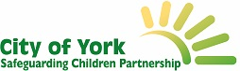
City Of York 7 Point briefing: Baby Thomas- Learning from Practice

Baby Thomas died as a result of Sudden Unexpected Death in Infancy (SUDI) aged just 12 days old. This single agency review looks at learning from health partners involved in the antenatal and immediate postnatal period.
Key learning:
- Greater Professional Curiosity
- Missed opportunities to assess the home environment
- Improving Information Sharing
- SUDI prevention- consideration of accumulative risk factors
- Possible risks associated with fathers and/or their vulnerabilities are considered

Assessing and Responding to the Impact of Parental Mental Ill Health on children; The PAMIC tool

Just a quick reminder about the PAMIC tool that you can use to consider how likely and with what severity an adult's mental ill health will impact on a child. It supports your assessment and decision making. Take a look

There is also a video produced by TEWV that discusses the PAMIC tool in more depth. You can access it here

North Yorkshire: Social and Emotional Health Offer for Children and Young People
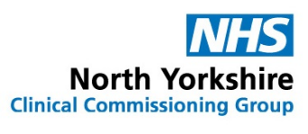
This document summarises the services offered for Children and Young People in North Yorkshire to support their emotional and social health and gives details on how to contact them.
Domestic Abuse Act (2021)
The Domestic Abuse Act is set to provide further protections to the millions of people who experience domestic abuse, as well as strengthen measures to tackle perpetrators.
Detailed factsheets on each new measure are available on gov.uk
Nicole Jacobs (Domestic Abuse Commissioner) has also launched a new Twitter account
@CommissionerDA and website. Take a Look

There is also an 'NHS Safeguarding' Briefing on the Domestic Abuse Act (2021) that you can view here
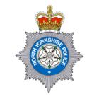
Increase your knowledge and awareness of Exploitation, Modern Slavery and Human Trafficking

This North Yorkshire Police webpage is a central hub for resources about Modern Slavery, take a look and increase your knowledge.
http://northyorkshire.police.uk/learnaboutexploitation

Please see details attached regarding a new tool which has been launched by Childline and Internet Watch Foundation (IWF) to help young people remove nude images that have been shared online.

We have updated our Primary Care Safeguarding Team contact lists- you can download them here:
You can also sign up for these really informative local safeguarding newsletters:
Best wishes
Nicky and Janette

For CYSCP bulletin click here

For NYSCP bulletin click here

