Rapid Diagnostic Service -Serious, Non-Specific Symptoms Pathway at Harrogate District Hospital
Following a successful pilot project and service evaluation we are delighted to be able to offer from 21st September 2021 a Suspected Cancer Pathway for Serious, Non-Specific Symptoms (SNSP) at Harrogate District Hospital.
The Rapid Diagnostic Service (RDS) at HDFT aims to provide a service for patients who present with concerning but non-specific symptoms which may represent a cancer, reduce hospital unnecessary appointments in both primary and secondary care and provide a holistic, coordinated and personalised package of care.
To enable the best outcome for the patient when referred, a battery of filter tests is required prior to referral (she referral flow chart). Referrals are made within eRS as a 2 week wait referral.
For patients who meet the referral criteria and are accepted following triage they will be reviewed in the nurse-led clinic within seven days of referral, holistically assessed and following MDT discussion the most appropriate investigations will be arranged.
SNSP REFERRAL CRITERIA
- Aged > 18 years
- Must NOT fulfil criteria for any other 2WW rule pathway
- Well enough to attend clinic/Ambulatory investigations PLUS
- New unexplained and unintentional weight loss (either documented ˃5% in three months or strong clinical suspicion)
- New unexplained vague abdominal pain for four weeks or more (less if very significant concern) with no associated change in bowel habit
- New unexplained constitutional symptoms for four weeks or more (less if very significant concern). Symptoms include loss of appetite, fatigue, nausea, bloating or malaise.
- GP ‘gut feeling’ of cancer diagnosis - reasons to be clearly described
- No diagnosis suggested by initial tests in Primary Care
Following investigations, patients are referred either to a relevant cancer MDT, referred to onward services if appropriate or discharged back to primary care.

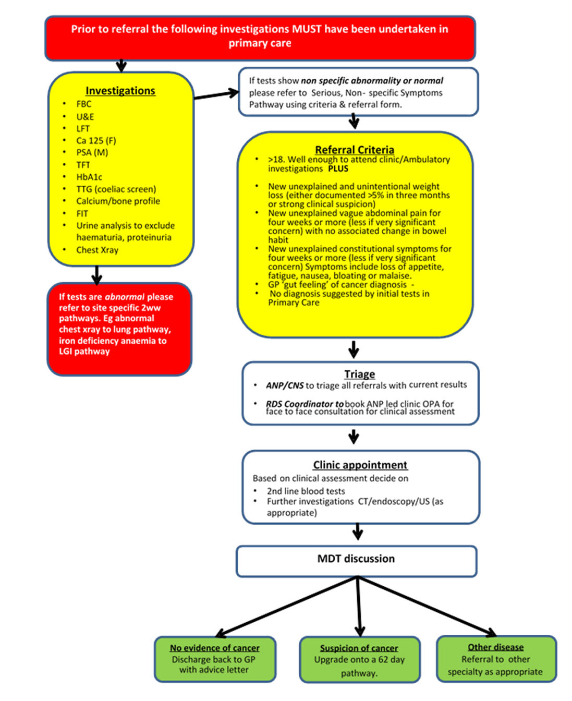

The team at Harrogate is led by Dr Adam Culverwell, Consultant Radiologist, Dr Ganesh Sivaji, Consultant Gastroenterologist and Mel Aubin Lead Nurse/ANP. It is supported by Mr John Simpson UGI Surgeon, Louise Gregg RDS Coordinator and later in the year we welcome along a RDS Clinical Nurse Specialist to the team.
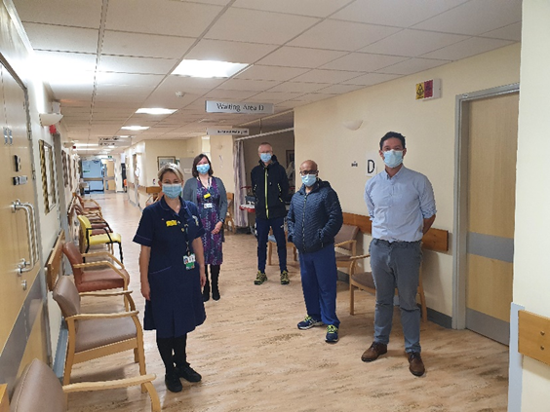

If you do have any questions regarding the service or a referral, then please don’t hesitate to give me a call or email:
Mel Aubin, Lead Nurse/ANP for RDS on: mel.aubin@nhs.net 01423 557981

