Key Messages for Families, Teachers and Health and Social Care Workers
- If there is a wee problem it could be a poo problem
Large and/or hard stool will have an impact on how the bladder works (poo problem), including causing wetting (wee problem).

- What a poo problem looks like

There are 7 different types of stools as shown below.

We are ideally aiming for a type 4 stool being passed most days.

We want to get rid of type 1, 2 and 3 stools, large stool, and straining and witholding behaviours.
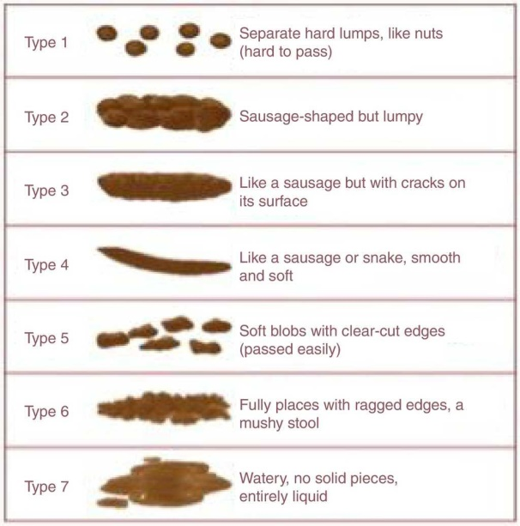
Correct diet of food containing enough soluble fibre (as found in e.g. oats, peas, beans, apples, citrus fruits and carrots), 5 portions of fruit and vegetable a day and adequate fluid intake (see section 3 below) is important in maintaining healthy bladder and bowel.
- How much water should a child be drinking?
Make sure your child is having 6-8 drinks of water-based fluid a day to help keep their bowel and bladder healthy.
Avoid fizzy drinks, drinks with caffeine in them and sugary drinks.
Don't limit their drinks to help them stay dry as it doesn't work. The bladder needs to be filled and emptied properly to keep it working well.

 | Total water intake per day including water contained in food | Water obtained from drinks per day  (120 ml = half a cup)
Infants 0-6 months | 700 ml  Assumed to be from breast milk (if a baby is exclusively breastfed, additional water is not required) | 600ml (2.5 cups)
7-12 months | 800ml  From milk and complementary foods and beverages | 600ml (2.5 cups)
1-3 years | 1300ml | 900mls (3.75 cups)
4-8 years | 1700ml | 1200ml (5 cups)
Boys 9-13 years | 2400ml | 1800ml (7.5 cups)
Girls 9-13 years | 2100ml | 1600ml (6.5 cups)
Boys 14-18 years | 3300ml | 2600ml (11 cups)
Girls 14-18 years | 2300ml | 1800ml (7.5 cups)
The above recommendations are for adequate intakes and should not be interpreted as a specific requirement. Higher intakes of total water will be required for those who are physically active or who are exposed to hot environments. It should be noted that obese children may also require higher total intakes of water

- How much urine should a healthy bladder be expected to hold?

What is the Expected Bladder Capacity (EBC)
It is calculated according to the formula (age +1) x 30 ml for children aged between 4 to 12 years
For example, a 9 year old boy has an expected bladder capacity of 300 mL (9+1 x 30 ml)
After the age of 12 years, the EBC is said to be constant.

How do you measure Bladder Capacity?
The bladder capacity can be obtained by measuring the amount of urine a child passes each time over a period of 4 days (during weekends/holidays).
The largest amount of urine at any single toilet visit during 4 days (excluding the 1st morning visit) is taken as the child’s bladder capacity.
If the child has been following a balanced diet and has been drinking enough water (as advised above) but the problem persists, speak to your GP for advice and treatment as needed.
The GP may refer the child to the specialist Bladder and Bowel team if further investigations or specialist treatment are needed. The team will provide you with information and advice on how you can support a child to develop healthy bladder and bowel function to help them to enjoy normal life.
The Bladder and Bowel team provide support for the following issues:
- Constipation
- Daytime Wetting
- Bedtime Wetting
- Toileting issues
- Continence Product support

For more information and advice on how to support children with developing healthy bowel and bladder habits please go to The Children’s Bowel and Bladder Charity website ERIC.

