Raising Concerns (Whistle Blowing)

Policy
June 2021
Authorship: | Corporate Services and EPRR Manager
Committee Approved: | Quality and Clinical Governance Committee
Approved date: | June 2021
Review Date: | June 2025
Equality Impact Assessment: | Yes
Sustainability Impact Assessment: | Yes
Target Audience: | Council of Members, Governing Body and its Committees and Sub-Committees, CCG Staff, agency and temporary staff & third parties under contract
Policy Number: | NY-131
Version Number: | 0.1

The on-line version is the only version that is maintained. Any printed copies should, therefore, be viewed as ‘uncontrolled’ and as such may not necessarily contain the latest updates and amendments.

POLICY AMENDMENTS
Amendments to the Policy will be issued from time to time. A new amendment history will be issued with each change.

New Version Number | Issued by | Nature of Amendment | Approved by & Date | Date on Intranet
0.1 | Corporate Services and EPRR Manager | New Policy | QCGC, Oct 2021

Contents

1.0 Introduction 4

2.0 Purpose 4

3.0 Policy Aims 5

4.0 Scope of the Policy 6

5.0 Duties, Accountabilities and Responsibilities 6
5.1 Responsibilities of the CCG 6
5.2 Responsibilities of Managers 6
5.3 Responsibilities of Employees 7
5.4 Responsibilities of Human Resources 7
5.5 Responsibilities for Approval 7

6.0 NHS Constitution 7

7.0 Principles 7

8.0 The Public Interest Disclosure Act 1998 8

9.0 Confidentiality 8

10.0 How to Raise a Concern 9
10.1 Step One 9
10.2 Step Two 9
10.3 Step Three 10

11.0 Investigating Process 11

12.0 Help and Advice 11

13.0 Public Sector Equality Duty 12

14.0 Anti-Fraud, Bribery and Corruption 12

15.0 Consultation 14

16.0 Training 14

17.0 Monitoring Compliance with the Document 14

18.0 Arrangements for Review 14

19.0 Dissemination 14

20.0 Associated Documentation 14

21.0 References 14

22.0 Appendices 15

23.0 Appendix 1 – Freedom to Speak up Diagram 16

24.0 Appendix 2 - Guidance to Staff 17

26.0 Appendix 3 – A vision for raising concerns in the NHS 18

27.0 Appendix 4 - Summary of The Public Interest Disclosure Act 1998 19
This policy has been assessed using an Equality Impact Assessment and Sustainability Impact Assessment. These assessments are recorded in the relevant registers and available to view on the CCG website.

Introduction
All of us at one time or another have concerns about what is happening at work. Usually, these concerns are easily resolved. However, when they are about patient care or patient services, professional practice, unlawful conduct, dishonesty, financial malpractice, or a danger to health, safety or the environment, or a cover up of any of these, it can be difficult to know what to do.
You may be worried about raising such issues or may want to keep the concerns to yourself, perhaps feeling it is none of your business or that it is only a suspicion. You may feel that raising the matter would be disloyal to colleagues, managers or to the CCG. You may have said something but found that you have spoken to the wrong person or raised the issue in the wrong way and are not sure what to do next.
NHS North Yorkshire Clinical Commissioning Group (CCG) introduced this policy to enable you to raise your concerns or suspicions about any issues of malpractice at an early stage and in the right way. We know from experience that to be successful we must all try to deal with issues on their merits. The CCG welcomes your genuine concerns and is committed to dealing responsibly, openly, and professionally with them. Without your help, we cannot deliver a safe service and protect the interests of patients, staff, and the CCG. If you are worried, we would rather you raised it when it is just a concern than to wait for proof.
If something is troubling you which you think we should know about or look into, please use this procedure. However, if you are aggrieved about your personal position or matters relating to your employment then this is not the appropriate procedure and you should seek advice from your manager or Human Resources (HR) team.
Please note that if you wish to raise concerns relating to potential fraud, bribery or corruption offences, there is a different procedure to follow. Please refer to the Anti-Fraud, Bribery and Corruption Policy for further advice.
This policy is primarily for concerns where the interests of others, most especially Service Users, or of the CCG itself, are at risk.
If in doubt – raise it!

Purpose
The CCG is committed to the principle of public accountability. The CCG will investigate all concerns expressed by employees relating to malpractice within the CCG and will ensure that employees are not discriminated against or suffer a detriment as a result of making such a disclosure, as laid down by the Public Interest Disclosure Act 1998 (PIDA).
The CCG encourages all individuals to raise any concerns that they may have about the conduct of others in the CCG or the way in which it is run.
This policy incorporates the requirements of the Public Interest Disclosure Act 1998 (PIDA) and the Bribery Act 2010. Where instances of fraud are identified these should be reported immediately to the Chief Finance Officer or the Local Counter Fraud Specialist (see 24.0) The Local Counter Fraud Specialist will investigate any allegation of fraud in order to establish if any offences have been committed, following guidance from the NHS Counter Fraud Authority. Where appropriate the Local Counter Fraud Specialist may refer the matter onwards to the police. Please refer to the CCG's policy on Anti-Fraud, Bribery and Corruption. One of the basic principles of public sector organisations is the proper use of public funds and this would include the assets bought through public funds. It is therefore important that all CCG employees are aware of the rules against any acts involving bribery, dishonesty, corruption or damage to CCG property. For simplicity all such offences are hereafter referred to as “fraud”.
Where safeguarding concerns are raised these should be reported immediately to the responsible safeguarding officer in line with the safeguarding policy.
The three fundamental public service values underpinning the NHS and all public sector work, specified by the NHS Code of Conduct for Boards published by the NHS Executive in April 1994 are Accountability, Probity and Openness. All those who work in the public sector should be aware of, and act in accordance with, these values. Acting with honesty and integrity forms a cornerstone of the public sector values.
The CCG is a public sector body and its employees are required to be honest and impartial in the conduct of their business. All employees of the CCG should be aware of the Standards of Business Conduct documentation published on the CCG’s intranet. The Governing Body is absolutely committed to maintaining an honest, open and well-intentioned atmosphere within the CCG.
The Francis 2 reports requires ‘Every Healthcare organisation and everyone working for them must be honest, open and truthful in all dealings with patients and the public, and organisational and personal interests must never be allowed to outweigh the duty to be honest, open and truthful’.
All employees have a duty to report instances where they witness others failing to demonstrate the expected levels of integrity in their working life. This will include bribery, fraud, corruption or bringing the CCG, the NHS or wider public service into disrepute.
This policy should be read in conjunction with the guidance in Appendix 1 - Freedom to Speak up Diagram and Appendix 2 - Guidance to Staff.
Appendix 4 - Summary of The Public Interest Disclosure Act 1998, provides a summary of the PIDA Act 1998.

Policy Aims
This policy aims to:
- encourage employees to feel confident in raising concerns regarding the practice of the CCG,
- provide avenues for employees to raise those concerns and receive feedback on any action taken,
- ensure that employees receive a response to their concerns,
- reassure employees that they will be protected from possible reprisals, subsequent discrimination, victimisation or disadvantage if they have a reasonable belief that the disclosure is in the public interest.
This organisation also has separate policies to cover anti-fraud, bribery & corruption and safeguarding concerns which provide further guidance and details separate procedures for reporting these concerns. If your concern relates to a suspected incidence of fraud or safeguarding then please refer to the Local Anti-Fraud, Bribery and Corruption Policy or the Safeguarding adults and Safeguarding Children policies respectively. Please note that the principles of this policy will still apply.

Scope of the Policy
This policy applies to all CCG employees, Council of Members, Members of the Governing Body, members of its committees and sub-committees, Lay Members, any staff seconded to the CCG and contract and agency staff. Any reference to staff or individuals applies to all the aforementioned.

Duties, Accountabilities and Responsibilities

Responsibilities of the CCG
- To monitor this procedure and the concerns/issues that are raised as a result
- To provide a point of contact for staff who wish to raise concerns under the provision of this policy and who feel it is inappropriate to raise the matter through their Line Manager

Responsibilities of Managers
- Consider staff concerns carefully and (where necessary) to undertake an investigation
- Understand the difficult position that the individual staff member may be in
- Seek appropriate advice from your line manager or the Freedom to Speak Up Guardian
- Take prompt action to resolve the concern or refer on to a relevant senior manager.
- Keep the member of staff informed about the ongoing processes and/or proposed solution
- Regularly review situations that have been reported to them
- Ensure individuals who genuinely report concerns are not penalized or discriminated against in any way

Responsibilities of Employees
- Ensuring that the best standards of care are achieved
- Report their concerns to a member of CCG staff as outlined in this procedure
- Raising concerns in the public interest with a true belief that poor standards of practice have occurred

Responsibilities of Human Resources
- To advise the employee of the options open to them and the relevant Policy to follow
- To support any employee who wishes to bring a Whistleblowing complaint to the attention of the CCG
- Human Resources will provide guidance and support to line managers on the operation of this policy at all stages

Responsibilities for Approval
The Quality and Clinical Governance Committee is responsible for the approval of this policy document.

NHS Constitution
With respect to this policy the CCG supports the Principles of the NHS Constitution, particularly in relation to delivering the highest standards of excellence and professionalism

Principles
The CCG is committed to the principles of the Freedom to Speak Up review and its vision for raising concerns as contained in Appendix 3.
Any matter raised under this procedure will be investigated thoroughly, promptly and confidentially and the outcome of the investigation reported back to the employee who raised the issue.
All employees will be made aware of the policy on joining the organisation as part of the induction process and will be encouraged to read and understand the process. All existing staff will be made aware of the policy.
No employee will be disadvantaged for raising a matter under this procedure for raising a legitimate concern. Any form of bullying, harassment, retaliation or victimisation of a Whistle-blower will not be tolerated and will be dealt with in accordance with the disciplinary procedures. Where it can be demonstrated that an employee knowingly supplied false information when raising a concern, the organisations disciplinary procedure will be followed.
In the event that misconduct is discovered as a result of any investigation under this procedure the organisation’s disciplinary procedure will be invoked in addition to any external measures.
The CCG will treat all such disclosures in a confidential and sensitive manner. The identity of the individual making the allegation may be kept confidential so long as it does not hinder or frustrate any investigation. However, the investigation process may reveal the source of the information and the individual making the disclosure may need to provide a statement as part of the evidence required.
This policy encourages individuals to put their name to any disclosures they make. Concerns expressed anonymously are much less credible, but they may be considered at the discretion of the CCG. In exercising this discretion, the factors to be taken into account will include:
- The seriousness of the issues raised
- The credibility of the concern
- The likelihood of confirming the allegation from attributable sources.

The Public Interest Disclosure Act 1998
The above act provides protection for employees who raise legitimate concerns about specified matters. These are called “qualifying disclosures”. A qualifying disclosure is one made in good faith by an employee who reasonably suspects:
- a criminal offence;
- a miscarriage of justice;
- an act creating risk to health and safety;
- an act causing damage to the environment;
- a breach or failure to comply with any legal or professional obligation or regulatory requirement;
- bribery;
- financial fraud or mismanagement;
- unauthorised disclosure of confidential information;
- a concealment of any of the above is being or is likely to be committed.
It is not necessary for the employee to have proof that such an act is being, has been, or is likely to be committed, a reasonable belief that making the disclosure is in the public interest is sufficient.

Confidentiality
Employees raising a concern should be aware of the need to follow this procedure and in particular to maintain confidentiality. Allegations of Breaches in Confidentiality will be dealt with using the appropriate procedures, through the use of the CCG Disciplinary Policy.
The identity of the individual who has raised a concern will be protected on request and will not be disclosed without consent. Whether and how to proceed will be discussed with the whistle blower if the situation arises where the concern cannot be resolved without revealing their identity (for example, because there is an internal investigation or evidence is needed in court).
Any employee raising a concern must be aware that they may be asked to present evidence to substantiate any allegations made, and/or to provide a written statement. In addition, they may be asked to explain their allegations during any disciplinary proceedings that may result from them.

How to Raise a Concern
Employees should raise concerns in line with the following procedure. Please note that if you wish to raise concerns relating to potential fraud, bribery or corruption offences, there is a different procedure to follow. Please refer to the Anti-Fraud, Bribery and Corruption Policy for further advice

We will treat you with respect at all times and will thank you for raising your concerns. We will discuss your concerns with you, to ensure we understand exactly what you are worried about. We will tell you how long we expect the investigation to take and keep you up to date with its progress. Wherever possible, we will share the full investigation report with you (while respecting the confidentiality of others).
We all have a responsibility and duty (often reinforced in Professional Codes of Conduct) to draw to the attention of CCG management any anxieties or concerns which we may have in respect of the conduct of another employee where we consider that this conduct may be detrimental to the interests of patients and/or employees of the CCG. This includes instances which compromise or appear to compromise the standards laid down by the CCG, including Health and Safety, ethical behaviour, clinical governance, corporate governance or probity protocols. There may be implications for you as an individual if you do not raise your concerns with CCG management or, as a minimum, discuss the matter with your professional organisation.
The CCG has a three-step approach to reporting (see Appendix 1 – Freedom to Speak up diagram)

Step One
If you have a concern about any issue (except suspicions relating to fraud), we hope you will feel able to raise it in the first instance with your manager. This may be done in writing or verbally.

Step Two
If you don’t feel Step One is appropriate or it hasn’t worked, please raise the matter with a CCG Senior Manager or Director.
Alternatively, you can contact one of our Freedom to Speak Up Guardians, the contact details are available on the CCG website. If you are unsure who to contact please ask one of the advice bodies listed below or someone from the HR Team. The guardian roles are important roles identified in the Freedom to Speak Up review to act as an independent and impartial source of advice to staff at any stage of raising a concern, with access to anyone in the organisation, including the Accountable Officer, or if necessary, outside the organisation.
This person has been given special responsibility in dealing with whistleblowing concerns. To remain impartial the Freedom to Speak Up Guardian will not investigate matters that are raised to them but they will:
- treat your concern confidentially unless otherwise agreed
- ensure you receive timely support to progress your concern
- escalate to the board any indications that you are being subjected to detriment for raising your concern
- remind the organisation of the need to give you timely feedback on how your concern is being dealt with
- ensure you have access to personal support since raising your concern may be stressful.
If you want to raise the matter in confidence, please say so at the outset so that appropriate arrangements can be made. You will be asked if you would like to be written to summarising your concern and the action we proposed.

Step Three
If Step One and/or Step Two channels have been followed and you still have concerns, or if you feel that the matter is so serious that you cannot discuss it with any of the above, please contact one or more of the following:
- Human Resources Team
- Chair of the CCG - Dr Charles Parker - charles.parker@nhs.net
- CCG Lay Member – Kate Kennady - kate.kennady@nhs.net
- Any Director or Assistant Director.
This procedure is intended to provide employees with an opportunity within the CCG to raise concerns. If, however, they are not satisfied with any action taken and feel it is right to take the matter outside the CCG, they should ensure that they approach a suitable organisation such as the Care Quality Commission or other regulatory body and they do not disclose information which should properly remain confidential. Employees will need to confirm this with the person or organisation they decide to contact.
In light of the procedure laid down in this Policy it is expected that all employee concerns can be addressed and dealt with internally or externally, and without reference to the media. An employee who has exhausted all the locally established procedures and who has taken account of any initial advice which they may have been given may, as a last resort, consider speaking to the media. If the employee considers that the involvement of the media is appropriate, they should seek advice (or further advice) from professional or other representative organisations and preferably discuss matters further with their manager before taking this step.
Such action, if entered into unjustifiably, could unreasonably undermine public confidence in the services provided by your colleagues and the CCG. Employees are, therefore, strongly advised to first seek further specialist guidance as noted above.

Investigating Process
Due to the varied nature of issues raised, which may involve internal investigators and / or the police, it is not possible to lay down precise timescales and processes for such investigations. The investigating officer should ensure that the investigations are undertaken as quickly as possible without affecting the quality and depth of those investigations.
Where appropriate, and where they agree, the individual raising the concern will be offered the opportunity to provide further information into the investigation process.
The HR team shall advise those involved in the investigation in matters of employment law and other procedural matters.
Any potential disciplinary matters will be dealt with by the CCG in conjunction with HR and, where appropriate, relevant external bodies.
If the employee is not satisfied that their concern is being properly dealt with by the investigating officer, they have the right to raise it in confidence with the Accountable Officer / Clinical Chair, or one of the designated persons described above.
If the investigation finds the allegations unsubstantiated and all internal procedures have been exhausted, but the employee is not satisfied with the outcome of the investigation, the CCG recognises the lawful rights of employees and ex-employees to make disclosures to prescribed persons (such as the Health and Safety Executive or, where justified, other relevant external bodies).
In the rare and exceptional circumstance that the CCG makes a settlement agreement with an individual(s), the CCG will ensure that this is communicated openly and dealt with transparently. Any settlement agreements will be reported to the CCG Audit and Governance Committee and in the CCG’s Annual Report.

Help and Advice
At any point either before raising the concern or at any stage in this procedure an employee may involve a Trade Union or Professional Association Representative who will be able to provide help and advice.
Free, independent and confidential advice can be obtained from Speak up Direct, the NHS and Social Care Whistleblowing Helpline for NHS and Social Care on 08000 724 725.
In the NHS concerns can also be reported to the Department of Health via their Customer Service Centre on 0207 210 4850 or at http://www.dh.gov.uk/health/contact-dh/
Support and advice is available from Public Concern at Work and the NAO Controller and Auditor General at the following addresses:
Public Concern at Work - +44 (0) 191 516 7720
The Comptroller and Auditor General
National Audit Office
157-197 Buckingham Palace Road
London
SW1W 9SP
Telephone: 020 7798 7999
All CCG employees have access to Occupational Health and they offer a range of resources which will help employees to address stress and reduce the risk of resulting illnesses before, during and after an employee as raised a concern about the organisation. Contact details are below for the occupational health service;
Telephone; (01904) 725099 / (01723) 342168
Mediation services can be provided to the CCG at any stages of the whistleblowing process this will allow staff members resolve conflicts, rebuild trust or support staff that have raised a concern. The Human Resource team should be contacted if the CCG require this service then arrangements can be made.
If a CCG worker raises a concern through the whistleblowing process and as a result they cannot continue their employment, the CCG will consider applying the principles of the Re-deployment Policy as an offer of support where this is appropriate.

Public Sector Equality Duty
In developing this policy an Equality Impact Analysis (EIA) has been undertaken. As a result of performing the analysis, the policy, project or function does not appear to have any adverse effects on people who share Protected Characteristics and no further actions are recommended at this stage.

Anti-Fraud, Bribery and Corruption
The CCG has a responsibility to ensure that all staff are made aware of their duties and responsibilities arising from the Bribery Act 2010. Under the Bribery Act 2010 there are four criminal offences:
- Bribing or offering to bribe another person (Section 1);
- Requesting, agreeing to receive or accepting a bribe (Section 2);
- Bribing, or offering to bribe, a foreign public official (Section 6);
- Failing to prevent bribery (Section 7).
These offences can be committed directly or by and through a third person and, in many cases, it does not matter whether the person knows or believes that the performance of the function or activity is improper.
It should be noted that there need not be any actual giving and receiving for financial or other advantage to be gained, to commit an offence.
All individuals should be aware that in committing an act of bribery they may be subject to a penalty of up to 10 years imprisonment, an unlimited fine, or both. They may also expose the organisation to a conviction punishable with an unlimited fine because the organisation may be liable where a person associated with it commits an act of bribery.
Individuals should also be aware that a breach of this Act renders them liable to disciplinary action by the CCG, whether or not the breach leads to prosecution. Where a material breach is found to have occurred, the likely sanction will be loss of employment and pension rights.
The Local Counter Fraud Specialist will investigate cases of alleged Bribery or Fraud offences. There are several offences under the Fraud Act 2006, the most relevant for staff awareness are:
- Fraud by False Representation (Section 2)
- Fraud by Failing to Disclose Information (Section 3)
- Fraud by Abuse of Position (Section 4)
It is important to note that for each of these offences, the suspect does not need to successfully achieve a gain for themselves or another or cause a loss to someone else. If the intention to make a gain or cause a loss was present, then a fraud offence may be explored. Fraud offences that target the NHS cause significant damage in terms of financial loss, the undermining of public trust and by directly or indirectly compromising patient safety.
Fraud offences carry a potential sentence of up to 10 years imprisonment and application of unlimited fines. As with the Bribery Act 2010, if an employee is believed to have perpetrated fraudulent behaviour they may be subject to disciplinary action, civil legal proceedings and/or criminal prosecution. You can find out more about the CCG’s response to these offences in the Anti-Fraud, Bribery and Corruption Policy.
It is the duty of every member of staff to speak up about any genuine concerns in relation to criminal activity, breach of a legal obligation, miscarriage of justice, danger to health and safety or the environment and the suspected cover up of any of these in the workplace. To raise any suspicions of bribery and/or corruption please contact the Chief Finance Officer. Staff may also contact the Local Counter Fraud Specialist (LCFS) at – Audit Yorkshire, 07825 228 175 email: rosie.dickinson1@nhs.net
The LCFS will inform the Chief Finance Officer if the suspicion seems well founded and will conduct a thorough investigation. Concerns may also be discussed with the Chief Finance Officer or the Audit & Integrated Governance Committee Chair.
If staff prefer, they may call the NHS Fraud & Corruption Reporting Line on 0800 028 40 60 between 8am-6pm Monday-Friday or report online at www.reportnhsfraud.nhs.uk. This would be the suggested contact if there is a concern that the LCFS or the Chief Finance Officer themselves may be implicated in suspected fraud, bribery or corruption.

Consultation
This policy has been reviewed by relevant teams and individuals in the CCG. The document has also been shared with members of the North Yorkshire and Humber Social Partnership Forum.

Training
Staff will be made aware of the Policy via the staff newsletter and briefings

Monitoring Compliance with the Document
The policy and procedure will be reviewed periodically by the CCG in conjunction with operational managers and Trade Union representatives. The implementation of this policy will be audited at appropriate intervals and reported to the CCG Governing body.

Arrangements for Review
The policy will undergo a full review every 4 years. Earlier review may be required in response to exceptional circumstances, organisational change or relevant changes in legislation/guidance, as instructed by the senior manager responsible for this policy.

Dissemination
All employees will be made aware of the policy and will be encouraged to read and understand the process as part of the induction process.

Associated Documentation
The following documents should be referred to in conjunction with this policy.
- CCG Local Anti-Fraud, Bribery & Corruption Policy
- CCG Safeguarding Adults Policy
- CCG Safeguarding Children's Policy
- NHS Code of Conduct for Boards
- CCG Grievance Policy
- CCG Disciplinary Policy
- CCG Bullying and Harassment Policy
- Redeployment Policy
- CCG Compliments, Concerns and Complaints Policy

References
- Bribery Act (2010)
- Francis Inquiry Report (2013)
- NHS Code of Conduct for Boards (1994)
- NHS Constitution for England (2012)
- Public Interest Disclosure Act (1998)

Appendices
- Appendix 1 – Freedom to Speak up Diagram
- Appendix 2 – Guidance to Staff
- Appendix 3 – A vision for raising concerns in the NHS
- Appendix 4 – Summary of The Public Interest Disclosure Act 1998

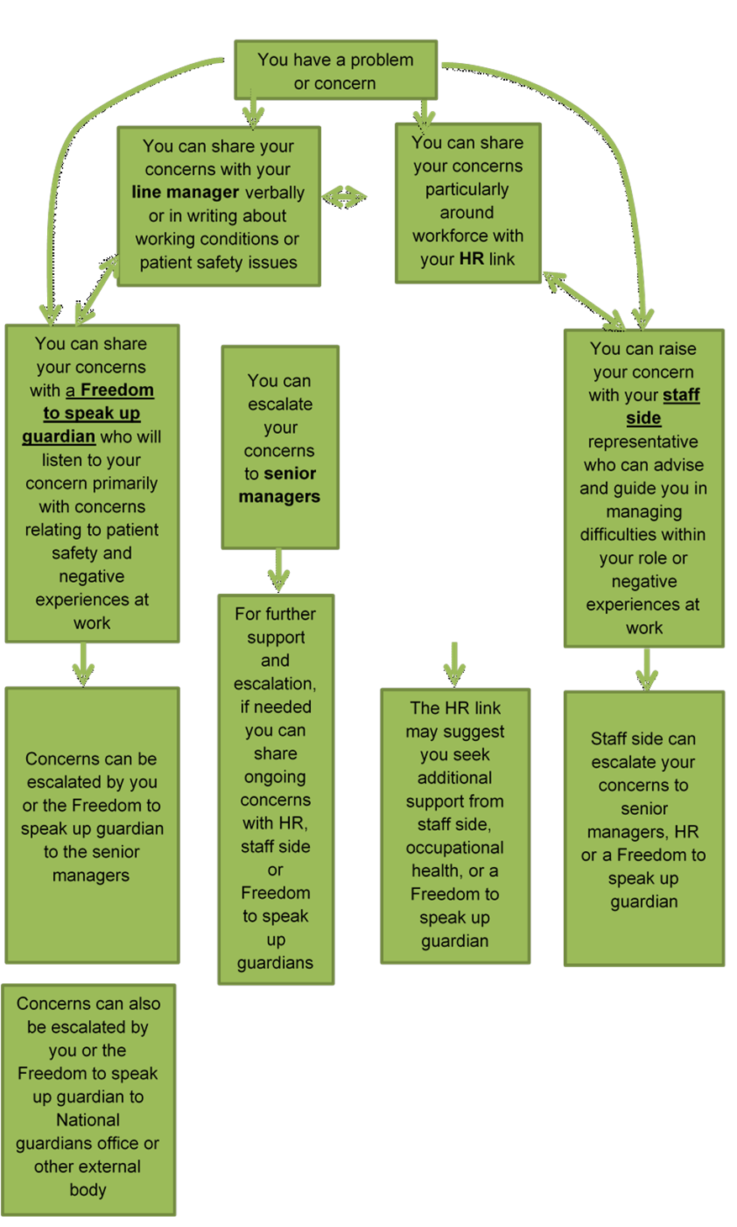
Appendix 1 – Freedom to Speak up Diagram

Appendix 2 - Guidance to Staff
Q - What should you do if you suspect malpractice?
- Please do make an immediate note of your concerns and retain any potential evidence (e.g. email trails, documents, meeting notes)
- Please do report the matter to an appropriate person – you can find advice on how to report your concerns within Section 10 of this policy
- If you suspect that fraud, bribery or corruption may have taken place please refer to the Anti-Fraud Bribery and Corruption Policy, and report the matter directly to the Local Counter Fraud Specialist, Chief Finance Officer or the NHS Counter Fraud Authority.
- Please do not ignore your concerns,
- Please do not try to investigate the matter yourself.
- Please only discuss your concerns with appropriate personnel. This is to reduce the risk of evidence being destroyed, damaged or tampered with.
GUIDANCE TO MANAGERS
- Do be responsive to staff concerns
- Do note details
- Do try to evaluate the allegation objectively
- Do deal with the matter promptly
- Do advise the appropriate person:
  - Line Manager
  - Human Resources
  - Chief Nurse, Director of Nursing and Quality
  - Head of Corporate Services, Governance and Performance
  - Chief Finance Officer
  - Local Counter Fraud Specialist
  - Safeguarding Officer
- Don’t ridicule suspicions raised by staff
- Don’t approach or accuse any individuals directly
- Don’t convey your suspicions to anyone other than those with the proper authority
- Don’t try to investigate the matter yourself

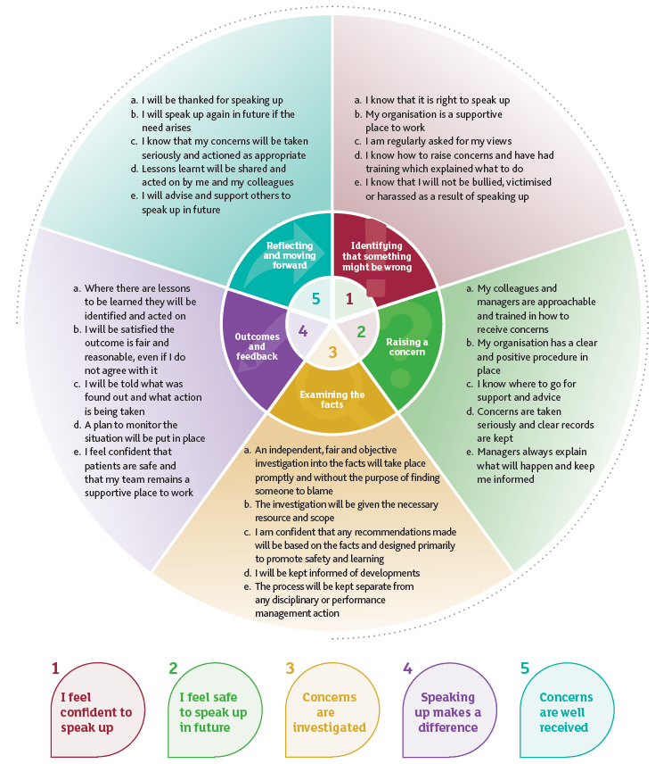
Appendix 3 – A vision for raising concerns in the NHS

Appendix 4 - Summary of The Public Interest Disclosure Act 1998
The Act applies to the public, private and voluntary sectors. It aims to improve accountability and good governance in all organisations by assuring workers concerned about malpractice that it is safe to raise their concerns. It also encourages employers to be receptive to such concerns and penalises them if they respond by victimising the worker.
The Act sets out the circumstances in which a disclosure of information may be protected. In brief, to obtain that protection, workers must act reasonably and responsibly. An employee who makes a rash disclosure (to the media for example, of a matter which could and should have been raised internally) will not be protected.
Only disclosures about specified types of malpractice may qualify for protection. A worker who is victimised or penalised for making a protected disclosure can bring an action for compensation against the employer at an employment tribunal.
Malpractice
The Act applies to people at work raising genuine concerns about crime, failure to comply with any legal duty (including negligence, breach of contract, breach of administrative law), miscarriage of justice, danger to health and safety or the environment, and the cover up of any of these. In the NHS this includes a worker raising concerns about risks to patients or about financial malpractice. It applies whether or not the information is confidential and whether the malpractice is occurring in the UK or overseas.
Individuals Covered
In addition to employees, the Act covers other workers, trainees, agency staff, homeworkers and all self-employed NHS professionals (i.e. doctors, ophthalmologists, dentists and pharmacists). The usual employment law restrictions on minimum qualifying period and age do not apply. It does not cover the genuinely self-employed (other than in the NHS), volunteers, the intelligence services, army or police officers.
Internal Disclosures
A disclosure to the employer will be protected if the employee (often referred to as a “whistleblower”) has an honest and reasonable suspicion that the malpractice has occurred, is occurring or is likely to occur. Where a third party is responsible for the malpractice, this same test applies to disclosures made to it.
Legal Advice
To ensure that people concerned about malpractice can get independent and confidential advice about how the Act works, disclosures to lawyers are protected.
NHS and Quangos
To promote accountability in public life, the same protection as for internal disclosures applies where someone in the NHS or a public organisation blows the whistle direct to the sponsoring department. There is no requirement that such concerns be raised internally first.
Regulatory Disclosures
Special provision is made for disclosures to organisations, which are prescribed under the Act. Those relevant to the NHS are:
- Public sector finance – Audit Commission
- Fraud and fiscal irregularities – Serious Fraud Office, Inland Revenue, Customs and Excise
- Health and Safety dangers – the relevant enforcing authority (Health & Safety Executive or Local Authority)
- Environmental dangers – the Environment Agency
- Others – Charity Commission, Occupational Pensions Regulatory Authority
Such disclosures will be protected where the whistleblower meets the tests for internal disclosures and additionally, honestly and reasonably believes that the information and any allegation contained in it are substantially true.
Wider Disclosures
First, the concern must have been raised with the employer or a prescribed regulator, unless:
- The worker reasonably believed s/he would be victimized if s/he did do
- There is no prescribed regulator and the worker reasonably believed there would be a coverup
- The matter was exceptionally serious
If one of the above pre-conditions is met, and the Tribunal is satisfied that disclosure was reasonable, the whistleblower will be protected.
Wider disclosures (e.g. to the police, the media, MPs and non-prescribed regulators) are protected if, in addition to the tests for regulatory disclosures, they are not made for personal gain and the following provisions are met:
- In deciding the reasonableness of the disclosure the Tribunal will consider the identity of the person it was made to, the seriousness of the concern, whether the risk or danger remains, and whether the disclosure breached a duty of confidence the employer owed a third party.
- Where the concern had been raised with the employer or a prescribed regulator, the Tribunal will also consider the reasonableness of their response.
- Finally, if the concern had been raised with the employer, the Tribunal will consider whether any whistleblowing policy in the organisation was or should have been used.
Full Protection
Where a worker or employee is victimised for blowing the whistle in breach of the Act, s/he can bring a claim at an Employment Tribunal. The usual limits on awards in employment law will not apply under the Public Interest Disclosure Act. Workers and employees who lose their jobs in breach of the Act will be fully compensated for their losses. Awards for victimisation short of dismissal will also be uncapped and based on what is just and equitable in all the circumstances.
Where an employee (but not other workers) is dismissed for blowing the whistle, s/he may apply within seven days for an interim order. Where the Tribunal considers that the employee is likely to win at the full hearing, it will order that s/he keeps his/her job or is paid his/her wages pending the full hearing.
The provisions on interim relief do not apply to self-employed professionals in the NHS. Nor can a tribunal make a Re-employment Order where the contract of a self-employed professional has been terminated in breach of the Act. However, as such workers will be entitled to recover their full losses at an Employment Tribunal; re-employment may well be an option the employer may wish to consider in the event of a claim under the Act.
Gagging Clauses
Gagging clauses in employment contracts and severance agreements are void insofar as they conflict with the Act’s protection.
Criminal Offences
Where the disclosure of that information was itself a criminal offence, such as under the Official Secrets Act, the whistleblower will not be protected under the Act if s/he has or would have been convicted of the offence.
[Extract from the Public Concern at Work Briefing Pack]

