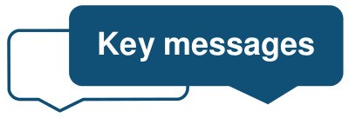
Safeguarding ….

These are key messages for Primary Care practitioners regarding children, young people and adults at risk of harm: March 2022
Access to patient records through the NHS App:

The NHSE website states that from April 2022, patients (16+) with online accounts such as through the NHS App will be able to read new entries in their health record. This applies to patients whose practices use the TPP and EMIS systems. However, there is still some uncertainty when this programme will exactly start.
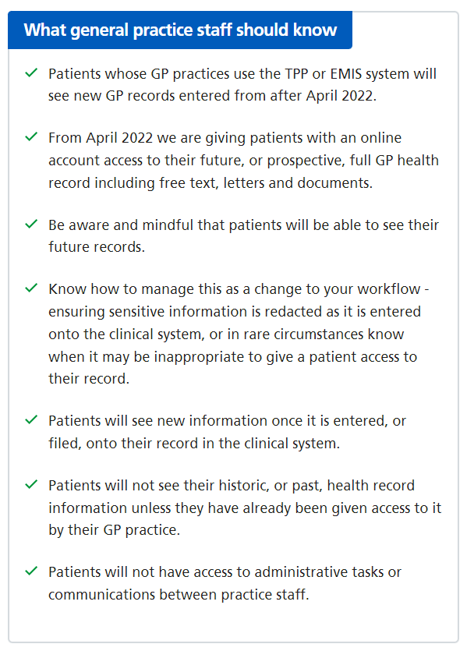
Please ensure you are aware of how to hide/block sensitive information from patient view as it’s entered on systems.

The decision as to whether the patient can view an entry will be taken, by the clinician, at the time of entering their notes onto the patient record

Consider and review the standard of note-keeping in your surgery

Ensure that any professionals from other agencies, such as midwives/Locums, that have access to, and make entries directly into patient records, are aware of this.

Please see information about this change and further guidance on the accelerating records access programme.

Please note: The information above is taken directly from the NHSE website
Hot Topics 2022/23: Level 3 Adults and Children Safeguarding Update Now available to Book!

We are really excited to share our New Hot Topics Virtual Level 3 Safeguarding training (via Microsoft teams) starting in May 2022.
Topics include:

• Domestic abuse (including the DA Act 2021 and Primary Care Policy 2022)
• Fabricated and Induced Illness (FII) and Perplexing Presentation
• SUDI (Sudden Unexpected Death in Infancy)
• LeDeR update
• Vicarious Trauma

Dates and Booking:

Tuesday 3rd May 2022 at (13:30 -16:00)
To book a place for the 3rd May 2022 please use the following link to eventbrite here

Wednesday 8th June 2022 at (13:30 – 16:00)
To book a place for the 8th June 2022 please use the following link to eventbrite here

Monday 18th July 2022 at (14:00 – 16:30)
To book a place for the 18th July 2022 please use the following link to eventbrite here

LPS (Liberty Protection Safeguards) and Primary Care:

- Many of you may be aware that the Deprivation of Liberty Safeguards are soon to change. They will now be called Liberty Protection Safeguards and the process will be different.
- In the future, GPs will be asked for the disorder of the mind or brain/mental impairment that the patient is suffering from which means they do not have the capacity to consent to their place and type of care.
- The letter in the link below explains the process and the interface with primary care.

Click here to read the Liberty Protection Safeguards communication to General Practice.

- Further information will follow the consultation of the revised Code of Practice for the Mental Capacity Act (MCA) and the Liberty Protection Safeguards (LPS). The consultation runs for 16 weeks from 17th March to the 17th July 2022.

Click here to read the MCA Code of Practice Consultation documents

- These 2 guides from 'communitycare.co.uk ' regarding the Draft MCA code of practice and LPS are a useful read.

https://www.communitycare.co.uk/2022/03/18/how-the-government-plans-to-implement-the-liberty-protection-safeguards/

https://www.communitycare.co.uk/2022/03/22/guide-to-the-draft-mca-code-of-practice/

Kooth:

Kooth delivered online chat/text-based counselling, discussion forums and online self-care resources for children and young people during the COVID-19 pandemic is and coming to an end (March 2022).
Please:
- Cease all promotion of the Kooth service including referring young people to the service
- Remove all links to Kooth on your local/organisational websites and replace with links to the other services available for children and young people in North Yorkshire and York

In North Yorkshire and York a range of national and locally-funded support for children and young people is now embedded, including:-

The Go-To Website –North Yorkshire. The website helps young people find the right help and support to stay well, whatever is happening in their life

YoungMinds Textline – free, 24/7 text support for young people across the UK experiencing a mental health crisis, with texts answered by trained volunteers supported by experienced clinical supervisors

BUZZ US Text messaging service – confidential advice, support and signposting from a wellbeing worker within one working day via text for young people aged 11-18 across North Yorkshire and York

There's further information regarding young peoples supportive services – including health professionals' referral forms – on the NHS North Yorkshire CCG website and the NHS Vale of York CCG website.

Perinatal Mental health – Presentation aimed at Maternity Staff, HV's and Primary care

This is an hour introductory teaching session from the Consultant Psychiatrist with the NY and York Perinatal team.

Provides an overview of relevant illnesses, their characteristics and how to screen for them, prescribing considerations and a brief outline of Major Perinatal Mental Health risk concerns.

Please take a look: https://youtu.be/R4jfJOdENTQ

Best Wishes Nicky, Bridget, Alison and Claire

