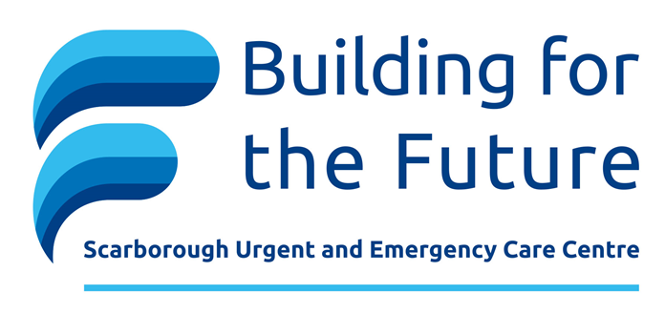

WHY we are building a new Urgent and Emergency Care Centre
- The Scarborough Acute East Coast Services Review, a detailed report on clinical services in the Scarborough area, identified in 2019 that Scarborough Hospital faces challenges around recruitment, sustainability, geography, and demography.
  - The local population is ageing and has changing health needs
  - A different type of healthcare service is required – one that results in decreased hospital activity
  - A new model of care was needed

- The current model of urgent and emergency care needed to change - the infrastructure at Scarborough Hospital dates from the mid-1980s. The increasing size and aging of the population, as well as increasing demand for urgent healthcare in society, has meant increasing attendances to Scarborough Emergency Department year on year for many years – and increase of around six percent per year.

WHAT we are doing
We are spending £47M to deliver a new urgent and emergency care centre by April 2024:
- A three storey capital build project that will transform the way we deliver care, provide state of the art critical care facilities for our sickest patients and upgrade our energy system
- Upgrade of engineering infrastructure and provide additional resilience to the site including power and water supplies and steam heating
- Additional car parking
- Thanks to a £500,000 donation by the HELP Appeal a new 31 square metre helipad, destined to help to save the lives of people living, working and visiting in the region, has been constructed. As a coastal town Scarborough faces unique challenges with its rural location and the sea on one side. The new larger helipad means that as well as landing the air ambulance, the much bigger search and rescue helicopter will also be able to land near the hospital, making a huge difference for incidents out to sea. By significantly reducing transfer times, patients with serious injuries, such as those caused by road accidents can be transported by air from rural locations.
Helipad facts
  - Construction took 12 weeks from starting on site to CAA approval to use as a helipad.
  - 550 tons of soil were removed from the build area
  - 660 tons of stone were used for the hardcore
  - 480 tons of tarmac were laid
  - 1,000m of electrical cable was used for the lighting
  - 2 tons of paint used for the helipad markings
  - 31 oak trees were removed from the build site and replanted elsewhere
FACTS and Figures
6,100 square metres of new clinical accommodation includes:
- AMM 87 treatment spaces available
- Critical Care 26 beds of which 18 are single/isolation rooms
- Additional 90 car parking spaces
- 231 foundation piles up to a depth of 12 metres
- No structural internal walls providing future flexibility
DESIGN considerations
  - inclusivity and accessibility
  - pandemic/isolation resilience
  - compliance with all relevant building specifications
  - enhancing patient’s and staff health and wellbeing and experience
  - art and wayfinding strategy
  - future digital aspirations
  - sustainability
  - adaptability and flexibility
  - privacy and dignity
  - infection control and prevention
  - future demand modelling

