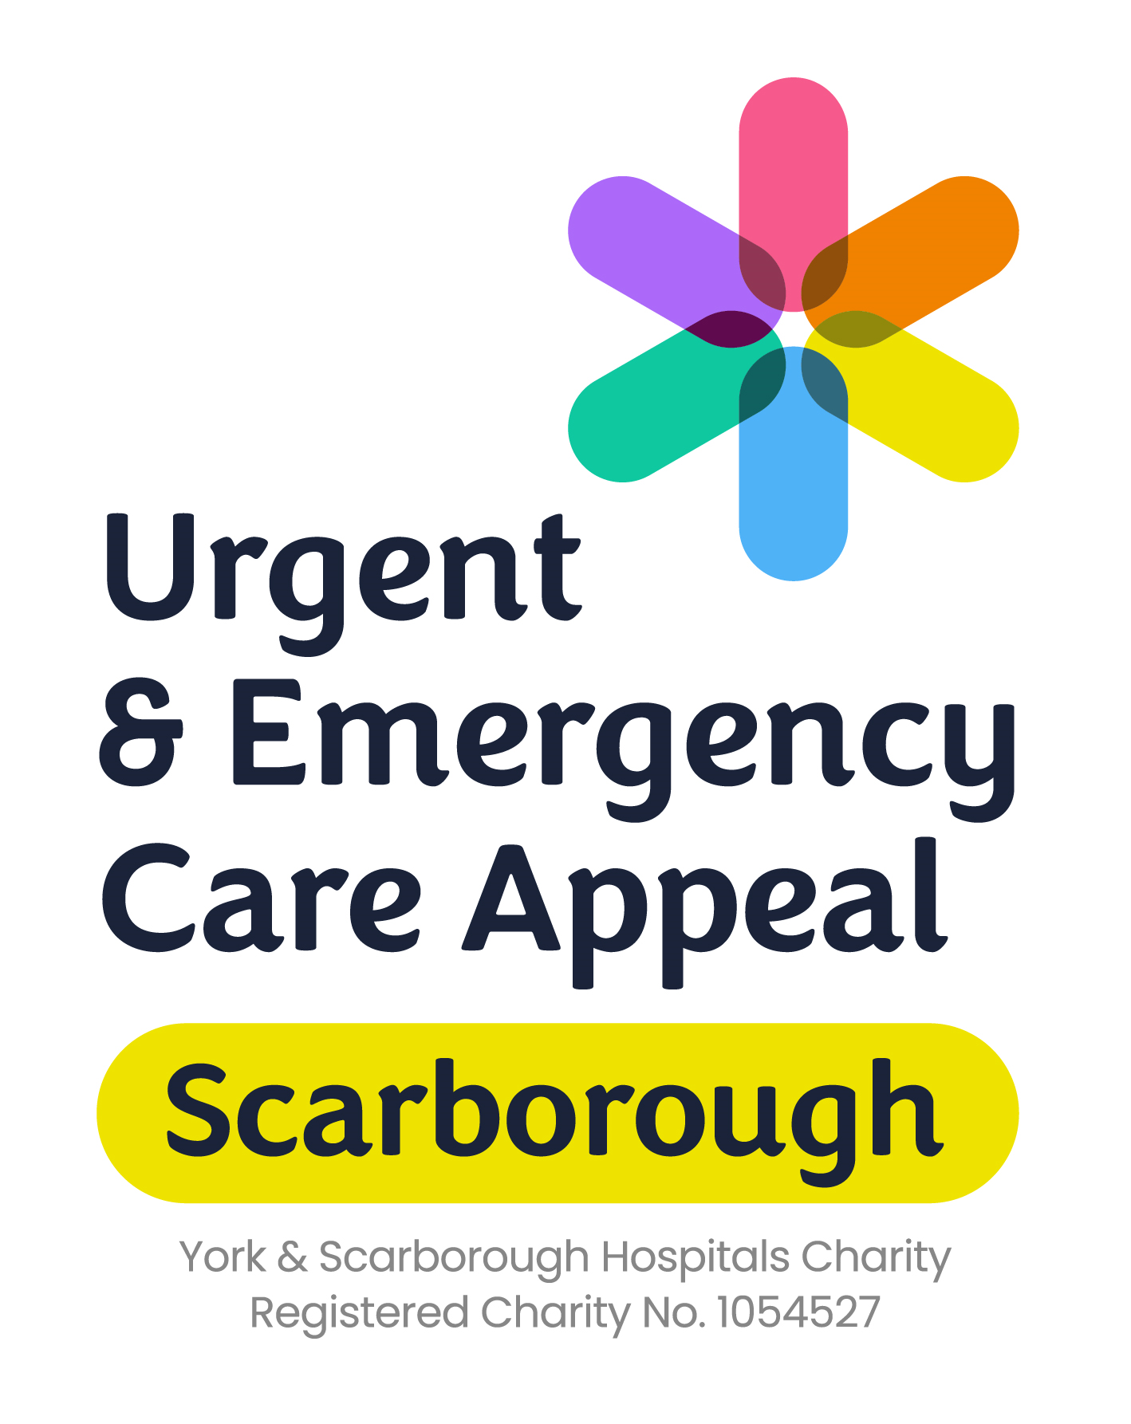

Help York & Scarborough Hospitals Charity raise £400,000 to enhance patient care and experience and support staff wellbeing in the new Urgent and Emergency Care Centre at Scarborough Hospital.

An exciting time for Scarborough
The Scarborough Urgent and Emergency Care Centre build is extremely good news for staff and for the community that Scarborough Hospital serves. It is the largest scheme ever undertaken by the Trust, and demonstrates commitment to the long term future of Scarborough Hospital.

The project will include a two-storey new build, combining and expanding the current emergency department, same day emergency care and the acute medical unit, and improving outcomes for the frail elderly.

The second floor will care for those patients with more critical needs in new intensive care, coronary care and high dependency units. It will ensure some of the poorliest patients in the hospital are cared for in one integrated clinical ward environment rather than being moved to other wards.

Why we need your support
York & Scarborough Hospitals Charity is raising money to fund the extras, over and above what can be funded as part of the scheme, to improve patient care and experience and improve staff wellbeing. This includes:
Fitting out specialist rooms
A mental health crisis room will give privacy to patients in crisis and provide a safe environment for staff if a patient becomes aggressive.
A multifunctional room will allow dignity, confidentiality and privacy for people with seen and unseen disabilities, children and people with mental health concerns.
Supporting relatives
Two ensuite relatives’ rooms within critical care will allow relatives to stay close to their family member and be reached quickly if the patient’s condition changes.
A private room will offer families access to a dignified and calm space to say goodbye if they have lost a loved one.

Improving the hospital environment
Artwork will be installed within the fabric of the building. A nature theme will run throughout with colour choices to help reduce aggressive behaviour and help with anxiety.
A ground floor patient garden, suitable for dementia patients, will allow people to get some fresh air while in the hospital.
A first floor terrace will provide an outdoor space for use by the sickest patients in the hospital and their relatives.

Enhancing staff wellbeing
During the coronavirus pandemic we learned that staff benefit from outside space to take breaks or to compose themselves after a difficult time. We will be funding two gardens especially for staff which will allow them to do this. The gardens will be accessible from the staff rooms so doors can be opened to allow fresh air and natural light in even in poorer weather.

Rachael spent five weeks in Scarborough Hospital after lifesaving surgery. She said the new Urgent and Emergency Care Centre will improve the experience for patients in so many ways.

“From my perspective, having an outdoor space where my bed could be wheeled out, would have been amazing. Not only would I have been able to see my family, but I could have felt fresh air on my skin. Due to Covid-19, my Mum wasn’t able to stay. Having Mum nearby would have made all the difference and for the charity to be able to fund the relatives’ room next door to the new ICU is just what families need and they have my full support.”

How can you help?
- Make a donation today using the form over the page
- Use the QR code to donate online
- Take on one of our challenges – do a run, go on a hike or even jump out of a plane!
- Get your workplace or school involved – hold a cake sale or dress down day. Don’t forget to ask if your workplace will match your fundraising total
- Ask your local pub, fish & chip shop or newsagents if they will take one of our collection tins on their counter
- Consider holding your own fundraising event, we can support you with marketing and promotional materials
Visit our website for more information and appeal updates www.ScarboroughUECAppeal.co.uk

Should the Scarborough Urgent and Emergency Care Appeal exceed its target, any additional monies raised will be used to further enhance the urgent and emergency care provision at Scarborough Hospital.
Should the appeal not reach the required target, York & Scarborough Hospitals Charity will ensure that donations are spent in accordance with its charitable objects. Funds raised will be prioritised to enhance the urgent and emergency care provision at Scarborough Hospital.
York & Scarborough Hospitals Charity reserves the right to revise the Urgent and Emergency Care Appeal target, should the expected costs of the project exceed initial estimates. The target of £850,000 was set based on best estimates of project costings available in March 2022. York & Scarborough Hospitals Charity has already committed £450,000 to the project and is aiming to raise a further £400,000.

