Images and suggested social media messages
DATE (w/c) | TOPIC | SOCIAL MEDIA MESSAGE
6-6-22 | Athlete's foot  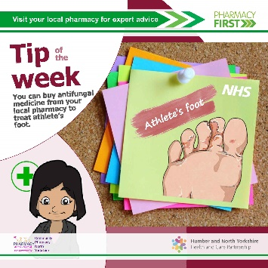 | Athlete's foot is a common fungal infection that affects the feet. You can usually treat it with creams, sprays or powders from a pharmacy. Find out more on the NHS website: https://www.nhs.uk/conditions/athletes-foot/
13-6-22 | Hay fever  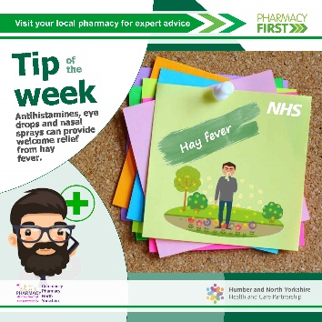 | There's no cure for hay fever, but there's plenty of things you can do to ease symptoms when the pollen count is high. Visit the NHS website for self-care advice: https://www.nhs.uk/conditions/hay-fever/ or your nearest pharmacy for effective remedies.
20-6-22 | Cuts and bruises  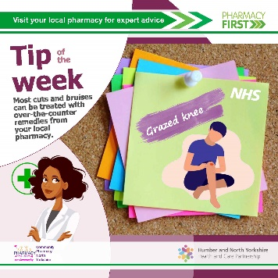 | Most cuts and grazes are minor and can be easily treated at home. Stopping the bleeding, cleaning the wound thoroughly and covering it with a plaster or dressing is usually all that's needed. Visit your nearest pharmacy or the NHS website for more advice: https://www.nhs.uk/conditions/cuts-and-grazes/
27-6-22 | Sun protection  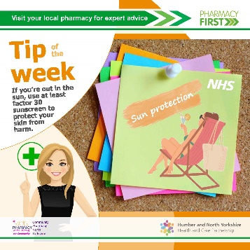 | Sunburn increases your risk of skin cancer. You can burn in the UK, even when it's cloudy and there's no safe or healthy way to get a tan. You can find out more about sunscreen and sun safety on the NHS website: https://www.nhs.uk/live-well/seasonal-health/sunscreen-and-sun-safety/
4-7-22 | Conjunctivitis  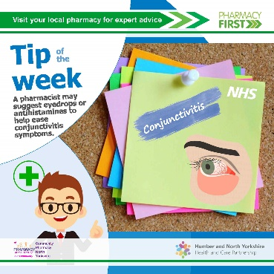 | Conjunctivitis is an eye condition caused by infection or allergies. It usually gets better in a couple of weeks without treatment. For self-help information, visit the NHS website: https://www.nhs.uk/conditions/conjunctivitis/
11-7-22 | Paracetamol  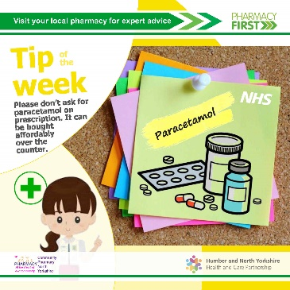 | Paracetamol is a common painkiller used to treat aches and pain and can also be used to reduce a high temperature. It's widely available over-the-counter. You can read more about paracetamol on the NHS website: https://www.nhs.uk/medicines/paracetamol-for-adults/
18-7-22 | Sun burn  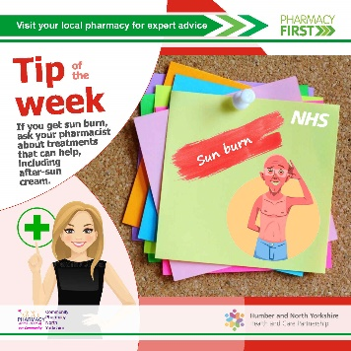 | Sunburn is red, hot and sore skin caused by too much sun. You can usually treat is yourself with over-the-counter remedies from your pharmacy, though in serious cases, you may need to see your GP or call NHS 111. Find out more on the NHS website: https://www.nhs.uk/conditions/sunburn/
25-7-22 | Insect stings  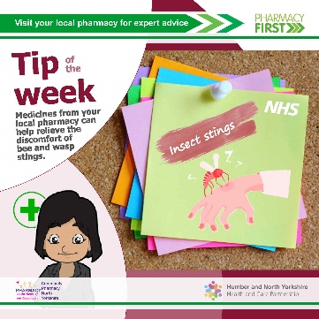 | Most insect bites and stings are not serious and will get better within a few hours or days. Creams from your pharmacy may help relieve pain and discomfort. In some cases you can have a more severe reaction. If you're worried, contact NHS 111: https://www.nhs.uk/conditions/insect-bites-and-stings/
1-8-22 | Dry eyes  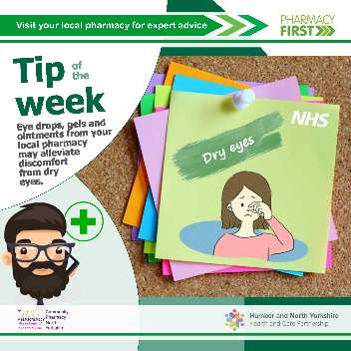 | If you have dry eyes, a pharmacist may be able to tell you what you can do to treat it yourself, if you can buy anything to help, like eye drops, gels, ointments or allergy medicines, and when you need to see an optician or GP. Find out more on the NHS website: https://www.nhs.uk/conditions/dry-eyes/
8-8-22 | Travel sickness  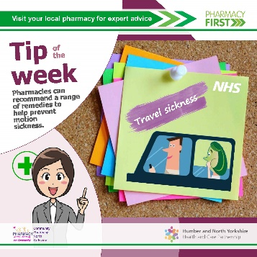 | Motion sickness is feeling sick when travelling by car, boat, plane or train. There are steps you can take to ease motion sickness. Remedies to stop travel sickness are also available from high street pharmacies. Visit the NHS website to find out more: https://www.nhs.uk/conditions/motion-sickness/
15-8-22 | Heat rashes  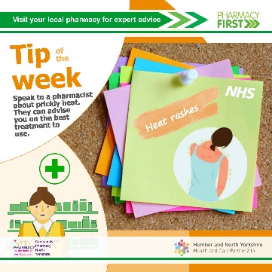 | Speak to a pharmacist about heat rash – sometimes called prickly heat. They can give advice and suggest the best treatment to use, such as calamine lotion, antihistamine tablets and hydrocortisone creams. Visit the NHS website to find out more: https://www.nhs.uk/conditions/heat-rash-prickly-heat/
22-8-22 | Indigestion  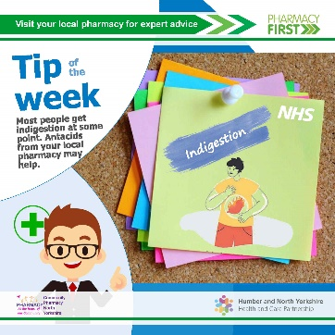 | Most people get indigestion at some point. Usually, it's not a sign of anything more serious and you can treat it yourself. Speak to your pharmacist for advice and remedies. Find out more on the NHS website: https://www.nhs.uk/conditions/indigestion/
29-8-22 | Dry skin  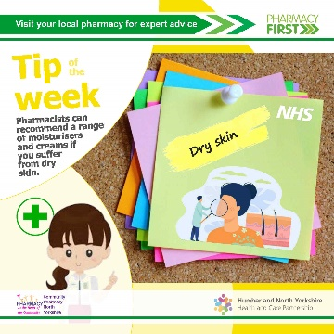 | Your high street pharmacy should be your first port of call if you have dry skin. They can recommend moisturisers and creams and point you to your GP surgery if it's a symptom of something more serious.
OPTIONAL
FOUR-WEEK
CAMPAIGN PAUSE

5-9-22  3-10-22 | Mouth ulcers  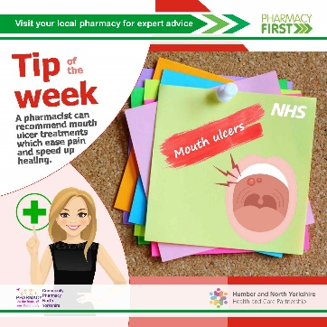 | Mouth ulcers are rarely a sign of anything serious, but may be uncomfortable. Special mouthwashes, painkilling tablets and corticosteroid lozenges are available from pharmacies without prescription. There's more advice on the NHS website: https://www.nhs.uk/conditions/mouth-ulcers/
12-9-22  10-10-22 | Multivitamins  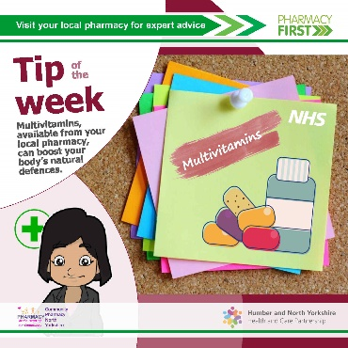 | Your high street pharmacy will stock a range of vitamins and multivitamins to boost your body's natural defences against illness. Speak to your pharmacist about your individual requirements.
19-9-22  17-10-22 | Constipation  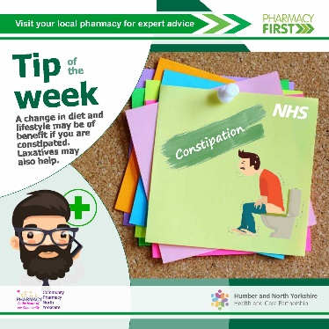 | Constipation is common and affects people of all ages. You can usually treat it at home with simple changes to diet and lifestyle. A pharmacist can also help. Find out more – including when you might need to see a GP – on the NHS website: https://www.nhs.uk/conditions/constipation/
26-9-22  24-10-22 | Vitamin D  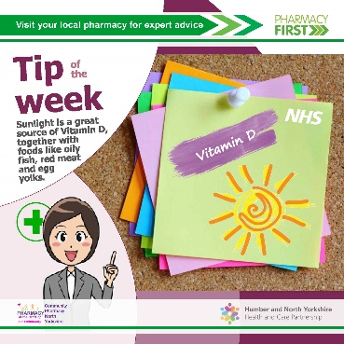 | The NHS recommends people take Vitamin D supplements during autumn and winter, as the sun is not strong enough and it's hard for people to get Vitamin D from food alone. Speak to your pharmacy team or visit the NHS website to learn more: https://www.nhs.uk/conditions/vitamins-and-minerals/vitamin-d/
3-10-22  31-10-22 | Piles  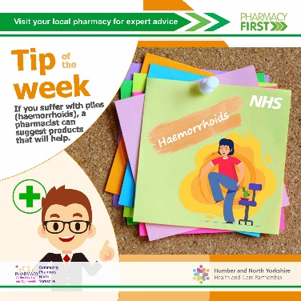 | Ask a pharmacist about treatment for piles. Many pharmacies have private areas if you do not want to be overheard. If there's no improvement after treatment, you may need to speak to your GP. Find out more on the NHS website: https://www.nhs.uk/conditions/piles-haemorrhoids/
10-10-22  7-11-22 | Thrush  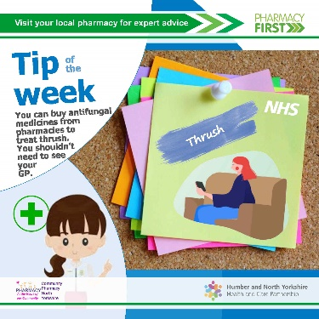 | Thrush is a common yeast infection that affects men and women. You can buy antifungal medicine from pharmacies if you've had thrush diagnosed in the past and you know the symptoms. Visit the NHS website to find out more: https://www.nhs.uk/conditions/thrush-in-men-and-women/
17-10-22  14-11-22 | Head lice  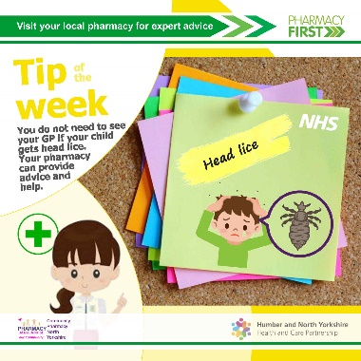 | Head lice and nits are very common in young children and their families. Medicated lotions and sprays are available from high street pharmacies that should kill the lice. There's more advice on the NHS website: https://www.nhs.uk/conditions/head-lice-and-nits/
24-10-22  21-11-22 | Cold sores  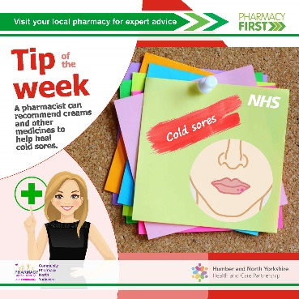 | If you have a cold sore, a pharmacist can recommend creams to ease pain and irritation, antiviral creams to speed up healing time and cold sore patches to protect the skin while it heals. Find more self-care advice on the NHS website: https://www.nhs.uk/conditions/cold-sores/
31-10-22  28-11-22 | Sore Throat  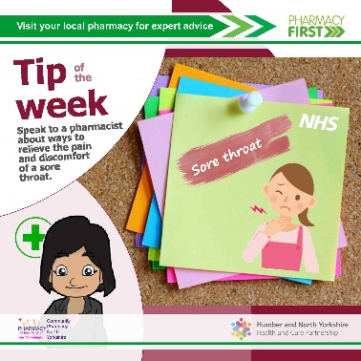 | Sore throats are very common and not usually anything to worry about. There are lots of remedies available from your local pharmacy and there's more self-care advice on the NHS website: https://www.nhs.uk/conditions/sore-throat/
7-11-22  5-12-22 | Diarrhoea  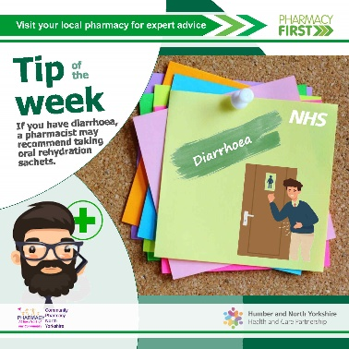 | Diarrhoea and vomiting are common in adults, children and babies. They're often caused by a stomach bug and should stop in a few days. You can get treatments from your local pharmacy. For more information, including when to get advice from NHS 111 or call 999, visit the NHS website: https://www.nhs.uk/conditions/diarrhoea-and-vomiting/
14-11-22  12-12-22 | Vitamin D  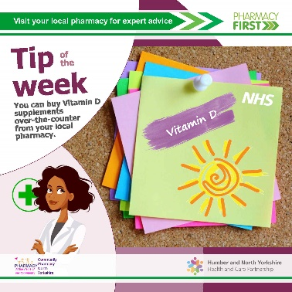 | If you think you may need Vitamin D supplements to boost your body's natural defences against illness, speak to your pharmacist. Find out more on the NHS website: https://www.nhs.uk/conditions/vitamins-and-minerals/vitamin-d/
21-11-22  19-12-22 | Paracetamol for children / cough syrups  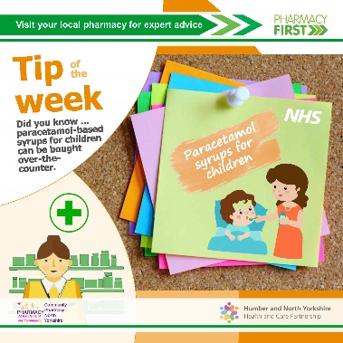 | You can get paracetamol-based syrups for children from your high street pharmacy without prescription. To learn more, visit the NHS website: https://www.nhs.uk/medicines/paracetamol-for-children/
28-11-22  26-12-22 | Dandruff  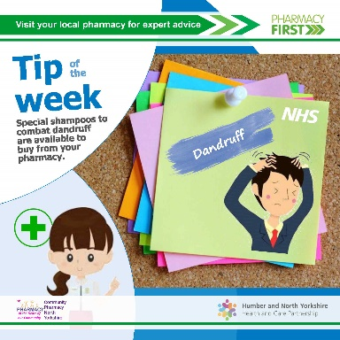 | You can treat dandruff yourself, using an anti-dandruff shampoo from your local pharmacy. Look for shampoos which contain zinc pyrithione, salicylic acid, selenium sulphide (or selenium sulfide), ketoconazole, OR coal tar. Visit the NHS website to find out more: https://www.nhs.uk/conditions/dandruff/
5-12-22  2-1-23 | Blocked nose  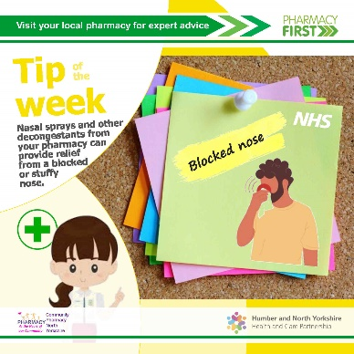 | Decongestants are a type of medicine that can provide short-term relief for a blocked or stuffy nose (nasal congestion). They can help ease the symptoms of conditions like colds and flu. Speak to a pharmacist about the best treatment to relieve your symptoms. There's more information on the NHS website: https://www.nhs.uk/conditions/decongestants/

