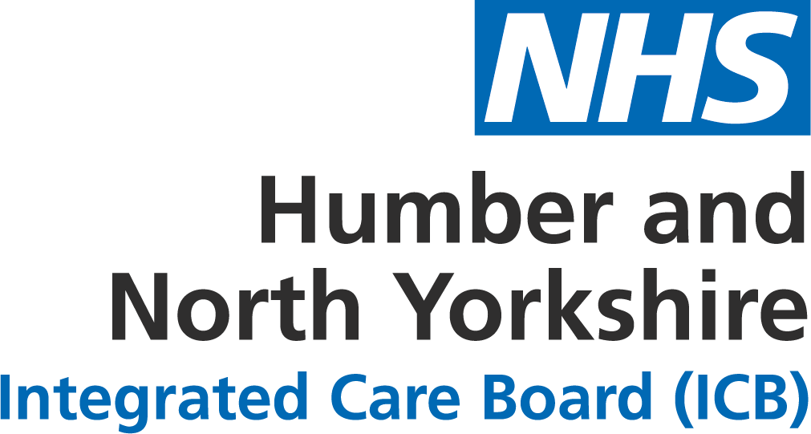

Humber and North Yorkshire Health and Care Partnership: update regarding changes from 1 July 2022
Humber and North Yorkshire Health and Care Partnership comprises of NHS organisations, local councils, health and care providers and voluntary, community and social enterprise (VCSE) organisations.
The Partnership is one of 42 Integrated Care Systems (ICSs) which cover England to meet health and care needs across an area, coordinate services and plan in a way that improves population health and reduces inequalities between different groups.
We work across a geographical area of more than 1,500 square miles and serve a population of 1.7 million people, all with different health and care needs. Our area includes the cities of Hull and York and the large rural areas across East Yorkshire, North Yorkshire and Northern Lincolnshire.
The Health and Care Act 2022 sets out plans to now put ICSs on a statutory footing, empowering partners to work closer together to better join up health and care services, improve population health, reduce health inequalities, enhance productivity and value for money, and help support broader social and economic development.
From 1 July 2022, each ICS will become led by an NHS Integrated Care Board (ICB) and an Integrated Care Partnership (ICP). Other important elements are place-based partnerships and provider collaboratives.
Integrated Care Boards will be accountable for NHS spend and performance within each ICS. They will take on NHS planning functions currently held by Clinical Commissioning Groups (CCGs), as well as some held by NHS England.
NHS Humber and North Yorkshire Integrated Care Board is due to be formally established on 1 July 2022 when its holds its first official meeting of the board. Details and papers regarding this meeting are available at www.humberandnorthyorkshire.icb.nhs.uk/meetings-and-papers.
We have been working towards 1 July 2022 for some time now and much work has taken place to prepare for the establishment of the ICB. We have appointed a full Executive Team and two Non-Executive Directors to be a part of the board, along with Partner Members who will cover Local Government, NHS Trusts and Foundation Trusts, and Primary Care.
Further details on the Executive Team and board members for the ICB are available at www.humberandnorthyorkshire.icb.nhs.uk/board-members.
Integrated Care Partnerships (ICPs) will operate as a statutory committee, bringing together the NHS and local authorities as partners to focus more widely on health, public health and social care.
We envisage the ICP structure will build out from those we serve: our population, service users and patients, and we believe that their needs and health aspirations are best met locally, at Place.
Membership of the ICP will be established and agreed with partners over the course of summer 2022 and meet formally for the first time in October 2022. However, Place leaders are at the very heart of our Partnership and it is our ambition for them to come together to form the ICP.
During the Autumn of 2022, the ICP will co-produce with partners, particularly Health and Wellbeing Boards and the ICB, an Integrated Care Strategy for Humber and North Yorkshire Health and Care Partnership to deliver.
Place-based partnerships between NHS, local councils and voluntary organisations, residents, people who access services, carers and families will lead design and delivery of integrated services in their local area.
Place Committees are being developed for each of the six places to enable increased autonomy and delegation of local decision-making to a formal joint committee.
It is anticipated that these place committees will receive delegated duties and resources from the ICB to make decisions about resourcing and services. They will also undertake joint decision-making at a Place level with Local Authority, VCSE and other bodies to improve local services and outcomes, using evidence such as practice/ward level population profiles.
A core member of each of these Place Committees will be an NHS Place Director appointed to the ICB, responsible for championing ICS strategies, policies and ambitions, managing staff locally in accordance with ICB policies and will also have delegated financial responsibilities.
Sector collaboratives bring providers and organisations from across Humber and North Yorkshire together, to work across the ICS with a shared purpose, set of priorities and effective decision-making arrangements. These collaboratives are an important part of ICS, working across a range of programmes and assist providers to work together to plan, deliver and transform services.
There are five sector collaboratives working together across Humber and North Yorkshire Health and Care Partnership, these are: Acute, Primary care, Community health and care, Mental health, learning disabilities and autism, and Voluntary, Community and Social Enterprise (VCSE).

