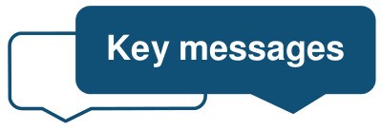
Safeguarding ….

These are key messages for Primary Care practitioners regarding children, young people and adults at risk of harm: June 2022
Safeguarding Training Opportunities
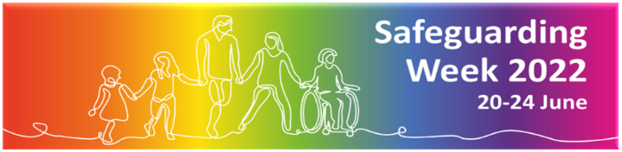
- Safeguarding week 2022 has over 53 sessions relating to adult and child safeguarding available between the 20-24th June.
- Click here to book onto session and please see the program attached
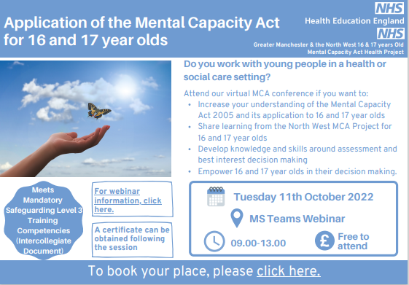
Application of the MCA for 16–17-year-olds: Webinar run by NHSE

Tuesday 11th October 2022
09.00-13.00

Click here to book

SUDI Basic Awareness Video. Access here

Health appointments advice for young people:
- This fantastic leaflet on health appointments is now available for young people.
- An RCPCH led project- this leaflet was developed along with other colleges and young people. It aims to improve young people's access to healthcare, help them understand the process and what might happen.
- See website to download – also see leaflet attached.
IDAS Support service for children and young people impacted by Domestic Abuse:
- For children age 10+ across North Yorkshire and York
- Offers 1:1 support and Group work
- To make a referral please visit the IDAS website, call 03000 110 110 or email: info@idas.org.uk
New CP Medical Assessment Information Leaflet for Parents and Carers:

- This new online leaflet explains the Child Protection Medical Assessment process followed to ensure that children are kept safe where there are concerns around possible neglect or abuse.
- You can access it here or via the QR code

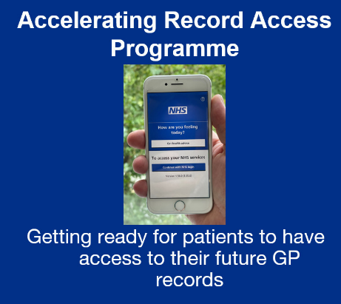

Go Live - now expected November 2022!

In the meantime you can read further information about the change, contact NHSX if you have any questions or access the awareness sessions.

Best Wishes Nicky, Bridget, Alison and Claire

