1 Grimbald Crag Court,
St James Business Park,
Knaresborough,
HG5 8QB

01423 799300
nyccg.enquiries@nhs.net
www.humberandnorthyorkshire.org

By email / hand delivered October 2022

Dear Accommodation Proprietor,

North Yorkshire NHS campaign: helping visitors access the right health services

We are writing this letter to ask for your assistance.

The NHS in North Yorkshire is embarking on a new campaign to help visitors to the Yorkshire Coast, Moors and Dales reach the right health services, quickly and efficiently, in the unfortunate event they become unwell.

As a tourist in less familiar surroundings, we understand it can be difficult to know where to go when help is needed. Some people will find the nearest hospital A&E department, even if it's a medical issue that could be easily and more appropriately dealt with by a local pharmacy, through NHS 111, or out-of-hours GP.

We want to help holidaymakers reach the right place in a timely manner – so they can receive treatment quickly and they have more time to enjoy their visit.

We've put together some posters, leaflets and social media packs for Autumn 2022, as well as content for website pages, to help our North Yorkshire visitors find the right care – and we are asking for your help to share these resources with your patrons, digitally and in print, where this is possible.

You can find more information about the campaign – and take a look at the campaign materials – here: www.northyorkshireccg.nhs.uk/on-holiday. You will find a sample of some of the posters and leaflets we've created, with this letter.

If you are willing to support this local NHS campaign, here are a couple of ideas for your consideration:-
- Share some of the information or website link (above), via email, at the time of customer booking – or in any subsequent correspondence ahead of the customer visit
- Display posters on noticeboards and in other areas where there is high footfall
- Include leaflets in any communal area leaflet stands or visitor 'welcome packs'
- Share information on your social media channels and e-bulletins
- Add a health page to your own website – feel free to crib the information at www.northyorkshireccg.nhs.uk/on-holiday

If you would like a batch of posters/leaflets, free of charge, please email hnyicb-ny.engagement@nhs.net with the quantity you require and who and where they should be delivered to and we will be delighted to make those arrangements.

If we can be of further assistance, please don't hesitate to get in touch with our North Yorkshire Communications and Engagement Team.

Yours sincerely,

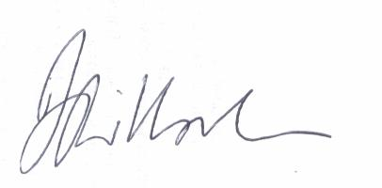

Dr Bruce Willoughby
NHS Humber and North Yorkshire Integrated Care Board

