Social media messages grid: Autumn 2022
If you're on holiday and have forgotten your medication, contact your GP surgery and they can arrange for your prescription to be sent to a pharmacy near you: www.nhs.uk/find-a-pharmacy  Find out more about accessing health services on holiday at https://tinyurl.com/yjzfm6au | 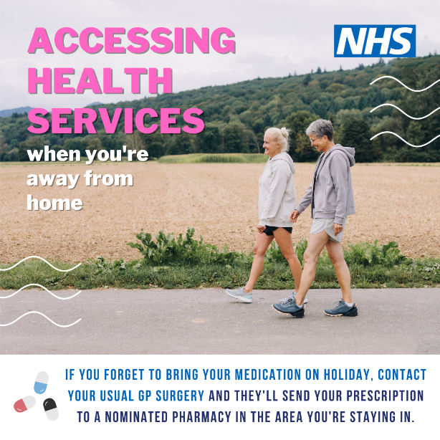
If you're on holiday and have forgotten your medication, contact your GP surgery and they can arrange for your prescription to be sent to a pharmacy near you: www.nhs.uk/find-a-pharmacy  Find out more about accessing health services on holiday at https://tinyurl.com/yjzfm6au | 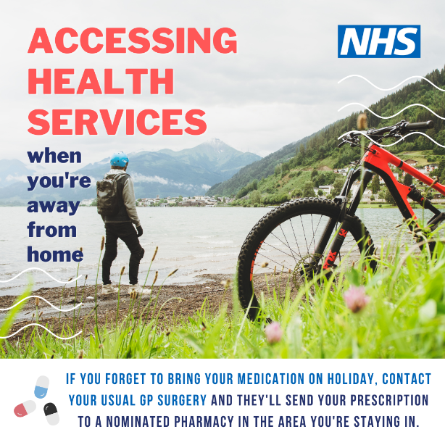
When you're in unfamiliar surroundings and you become unwell, contact NHS 111 online, via the NHS App, or call 111 and they can help you get the help you need: www.nhs.uk/111  Find out more about accessing health services when you're away from home: https://tinyurl.com/yjzfm6au | 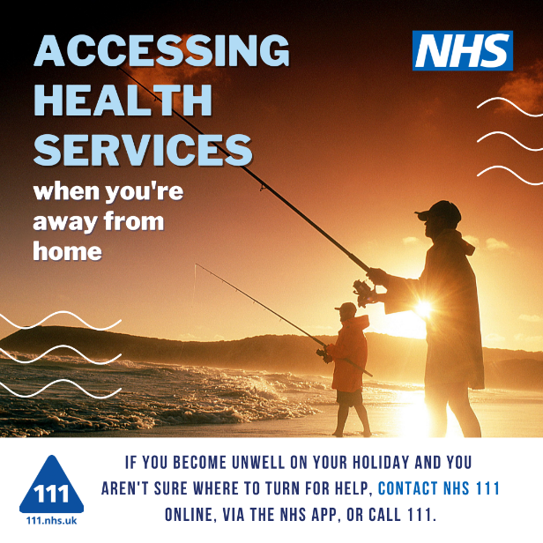
When you're in unfamiliar surroundings and you become unwell, contact NHS 111 online, via the NHS App, or call 111 and they can help you get the help you need: www.nhs.uk/111  Find out more about accessing health services when you're away from home: https://tinyurl.com/yjzfm6au | 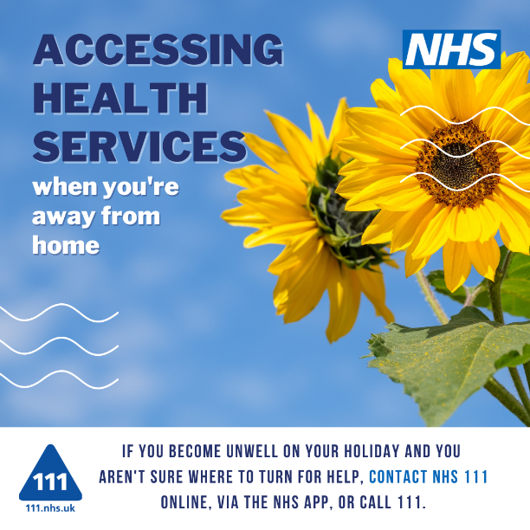
Add the NHS App to your holiday essentials list. It's a great companion to have with you, should you need to access health advice and services: www.nhs.uk/nhs-app/  Find out more about accessing health services when you're away from home at https://tinyurl.com/yjzfm6au | 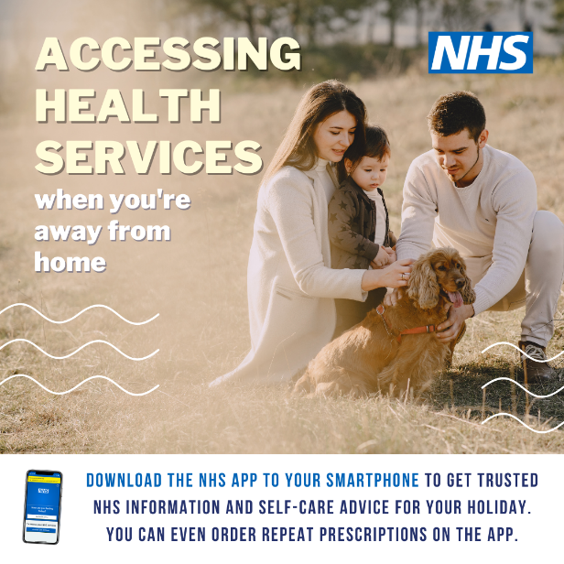
Add the NHS App to your holiday essentials list. It's a great companion to have with you, should you need to access health advice and services: www.nhs.uk/nhs-app/  Find out more about accessing health services when you're away from home at https://tinyurl.com/yjzfm6au | 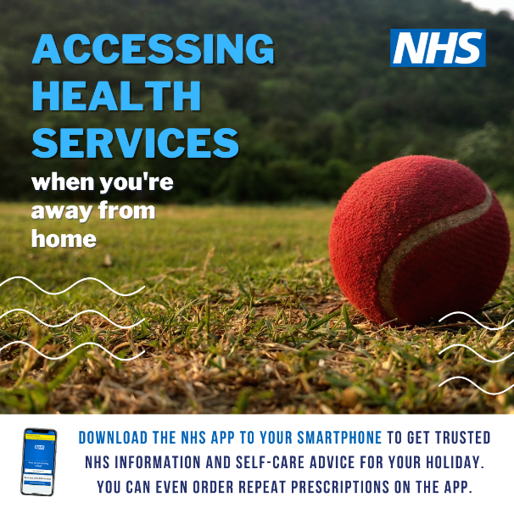
NHS 111 – online, through the NHS App or over the phone – is the place to go if you become seriously unwell during your holiday. In a life and limb emergency always call 999.  Find out more about accessing health services when you're away from home at https://tinyurl.com/yjzfm6au | 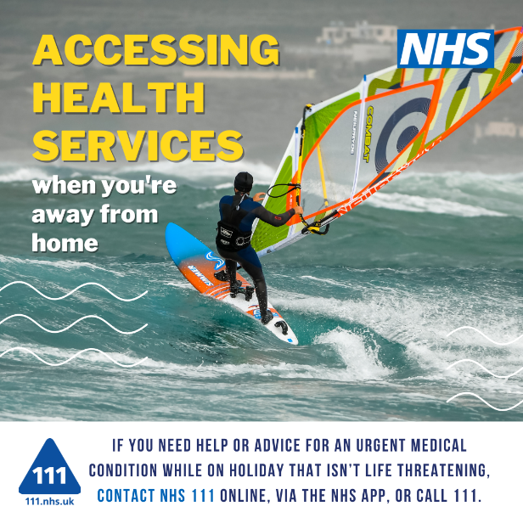
NHS 111 – online, through the NHS App or over the phone – is the place to go if you become seriously unwell during your holiday. In a life and limb emergency always call 999.  Find out more about accessing health services when you're away from home at https://tinyurl.com/yjzfm6au | 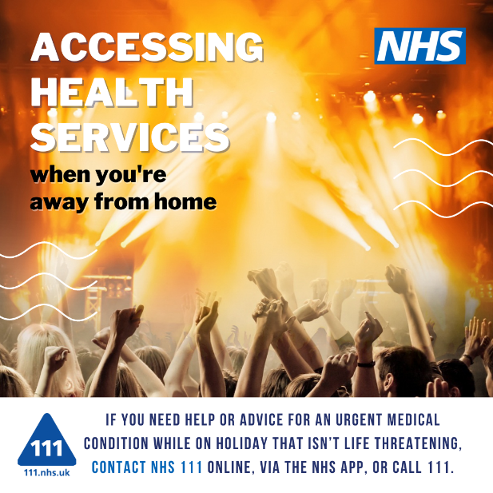
Pharmacy teams are experts in self-care and minor illness. If you're in unfamiliar surroundings you can find your closest pharmacy on the NHS website: www.nhs.uk/find-a-pharmacy  Find out more about accessing health services when you're away from home: https://tinyurl.com/yjzfm6au | 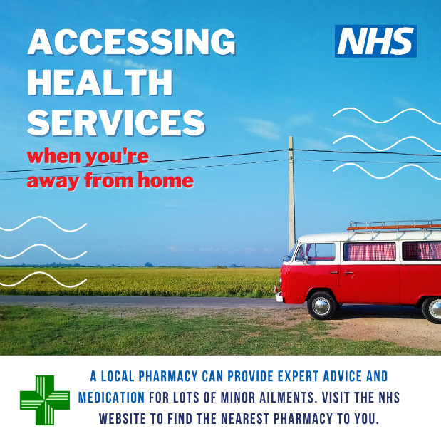
Pharmacy teams are experts in self-care and minor illness. If you're in unfamiliar surroundings you can find your closest pharmacy on the NHS website: www.nhs.uk/find-a-pharmacy  Find out more about accessing health services when you're away from home: https://tinyurl.com/yjzfm6au | 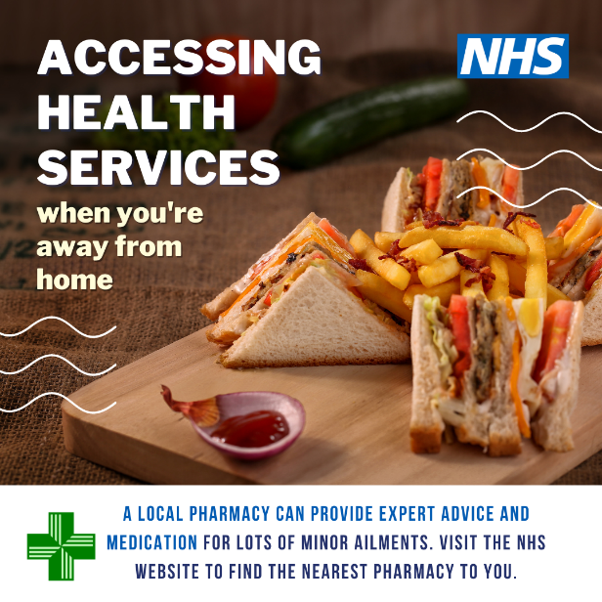
If you're on holiday and it's a health emergency, don't hesitate to call 999.  Find out more about accessing health services when you're away from home at https://tinyurl.com/yjzfm6au | 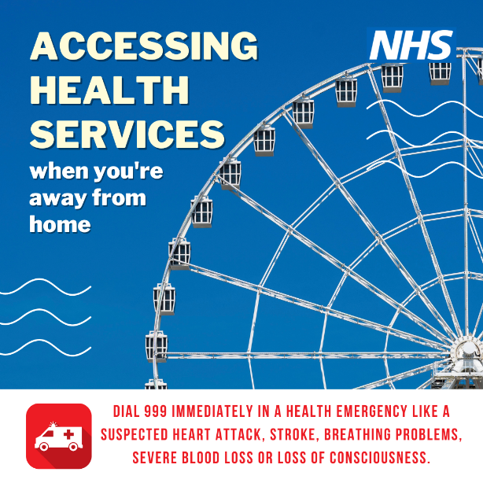
If you're on holiday and it's a health emergency, don't hesitate to call 999.  Find out more about accessing health services when you're away from home at https://tinyurl.com/yjzfm6au | 