NB: Optional image for top of page:

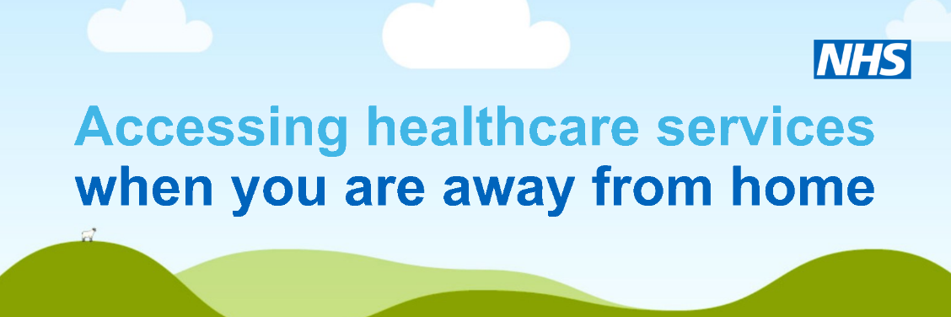

PAGE TITLE: Accessing health services during your holiday

Body text: We hope you have a safe and healthy holiday and don't need to access health and care services during your visit. But if you do become unwell the information below will help you reach the right care, first time.

Sub-header: Forget to bring your medication?

Don't panic – just contact your usual GP surgery in the same way you would normally (that could be online, or by telephone) and they will send your prescription to a nominated pharmacy in the area you're staying.

Sub-header: NHS App

If you have a smartphone, download the NHS App. It will give you access to trusted NHS information and self-care advice and you can even order repeat prescriptions and book appointments (in some areas). Find our more, here.

Sub-header: NHS 111

If you need help or advice for an urgent medical condition that isn’t life threatening contact NHS 111 – online (https://111.nhs.uk/), via the NHS App on your smartphone, or by calling 111. NHS 111 advisors will connect you with the right help and – depending on the nature of your problem – can even make an appointment for you at a local pharmacy or Urgent Treatment Centre.

Sub-header: Local Pharmacies

A local pharmacy can help with advice and over-the-counter medication for many routine minor ailments such as hay fever, sunburn, stings, bites, cuts and bruises, as well as tummy trouble and digestion issues. You can find your nearest pharmacy on the NHS website.

Sub-header: 999
This is the most appropriate service to contact if you have a 'life or limb emergency', such as suspected heart attack or stroke, breathing difficulties, severe blood loss or loss of consciousness. You can find out more about when to call 999 on the NHS website.

Sub-header: Be prepared with a first aid kit
You can be prepared for minor medical needs by keeping a first aid kit close to hand. Its contents may vary, depending on the time of year.

Summer travel bag essentials may include:-
- sunscreen
- insect repellent
- antihistamines
- pain relief, eg. paracetamol
- indigestion treatment
- anti-diarrhoea tablets
- plasters and sterile dressings
- antiseptic cream or sterile wipes
- a cream for bites and stings

For winter months, you may want to include cold and flu remedies.

A local pharmacist can help you find all of these items and would be happy to talk through any questions you have. You can find your nearest pharmacy on the NHS website.

Sub-header: Other useful links
Follow these links to find other services near you:-
- Urgent care services
- Sexual health services
- Pregnancy services
- Mental health services
- Dentist
- Optician
- GP
- Hospital
- Find other NHS services

NB: Optional image to use within page:

