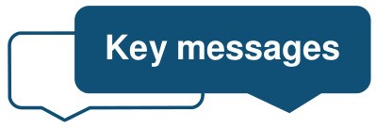
Safeguarding ….

These are key messages for Primary Care practitioners regarding children, young people and adults at risk of harm: Nov 2022
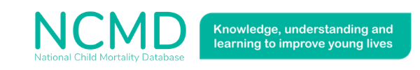
NCMD (National Child Mortality Database:

New guidance page added to the NCMD website. This page contains advice for GPs following the death of a child. The page explains how GPs can support families who have been bereaved, contribute to the Child death review process, and help reduce child mortality. Please share it whenever you have an opportunity!
https://www.ncmd.info/guidance/advice-for-gps-following-the-death-of-a-child/

Please also take a look at the poster on the 'GPs role in reducing inequalities in Infant Mortality' and the local free training opportunity on Child Death Reviews (see below).

Child Death Review: Advanced Training for Professionals 2022/2023
This course covers the different components of the child death review including the role and responsibilities of multi-agency professionals and provides the skills to explain it to families.

Dates:
- Thursday 10th November 2022, 10:00 – 12:00, via Microsoft Teams
Course Code NYS-OM-1122-T001
- Thursday 19th January 2023, 10:00 – 12:00, via Microsoft Teams
Course Code NYS-OM-0123-T001
- Thursday 9th March 2023, 10:00 – 12:00, via Microsoft Teams
Course Code NYS-OM-0323-T001
To book on the free training, please visit https://www.nyestraining.co.uk/ and enter the course code above.
Please note to book you will need to sign up and have a login (details for how to do this are on the website or you can call or email nyes@northyorks.gov.uk / 01609 533 222 and the team will set an account up for you.

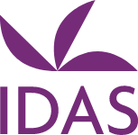
Domestic Abuse Training: Virtual (online)
Free training courses specific to professionals working within the North Yorkshire and City of York areas and are being delivered by our commissioned domestic abuse providers IDAS.

Target Audience: Professionals working with victims of domestic abuse and their children who work in the City of York and North Yorkshire areas.

Book online at IDAS Training for North Yorkshire and City of York Professionals webpage https://courses.idas.org.uk/north-yorkshire-and-city-of-york-training/
Child Sexual Assault Assessment Service for York and North Yorkshire:

The CSAAS is delivered by Mountain Healthcare Ltd and provides crisis support and forensic medical services for all children and young people aged 0 to 16 years who have disclosed sexual abuse or assault, or where it is suspected that it has happened.
Referrals can only be made from the police or children’s social care- please see attachment for further information or Mountain Healthcare website:
https://www.bridgehousesarc.org/professionals.html

• Advice available 24/7 via phone – 0330 223 1154

North Yorkshire: Free Parenting Courses for North Yorkshire Residents

Please see details for the Solihull parenting course below or for further details visit www.inourplace.co.uk – these are free courses for NY families and the access code is on the flyer: NYFAMILIES

North Yorkshire: Young Persons Guide to Mental Health Support:

The resources below are to ensure children and young people across North Yorkshire are aware of support available and can access the right support at the right time and include:
- A Young Person's guide to Mental Health Support . A resource created and designed by young people across North Yorkshire for young people to help them find the right support, whether it be finding out more information, talking to someone or accessing more specialised support
- A Mini Marketplace and a Needs based guidance for Social and Emotional Mental Health (SEMH) for Children and Young People In North Yorkshire to support professionals working with or parents and Carers with Children/Young People across North Yorkshire find the most appropriate mental health support based on a child/young person's needs.
All of these documents can be accessed and downloaded via the above links and the go-to website.
Hot Topics – level 3 Safeguarding Adult and Children Update Training Dates:

Booking information is on the flyer attached. These are free Microsoft teams 2 ½ hour teaching sessions from the Primary Care Safeguarding Team, please come along and join us.
Safeguarding Briefing Documents: Please share widely with colleagues and discuss within your practices.

Abusive Head Trauma:
Sub-conjunctival haemorrhage in babies and considerations for safeguarding:
Hypothermia:
'Partnership Achievement Award': We are extremely pleased to announce that Dr Joy Shacklock (Named GP for Child and Adult Safeguarding, GP Partner, and Practice Safeguarding Lead for The Spa Surgery and RCGP Safeguarding Representative) has received a 'Partnership Achievement Award' from the North Yorkshire Safeguarding Children Partnership for her outstanding work in this field.

Joy has been Named GP for Safeguarding in Primary Care (North Yorkshire) for over 8 years and has had a huge impact, supporting her primary care colleagues across the area, and sharing her expertise and passion for safeguarding. Joy is always an excellent advocate and ambassador for safeguarding and works tirelessly to progress national safeguarding practice for primary care for which we are extremely grateful.

Thankyou Joy for your hard work and dedication to safeguarding children, it is very much appreciated across the Partnership.

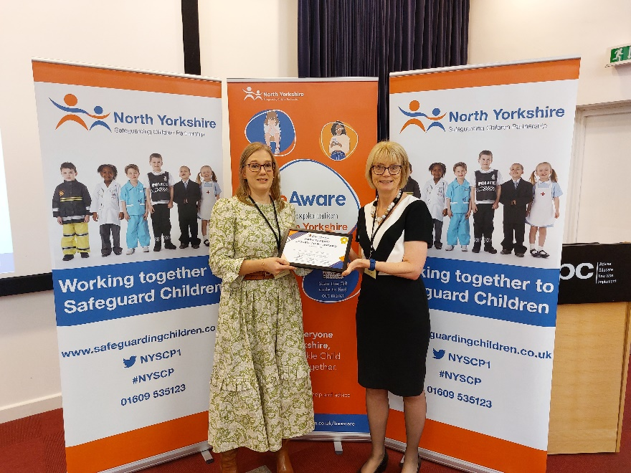

Best Wishes Nicky, Bridget, Alison, and Claire and our wonderful Named GP's Joy Shacklock and Pete Billingsley

