North Yorkshire and York Adult Autism and ADHD Assessment and Diagnosis Service Pathway
Does the patient meet the overall referral acceptance?
- The person is 18 years old or above at the time of the referral.
- The person’s substances and/or alcohol use is not at a level that may interfere with observational assessments/ability to engage in assessment process.
- The person is deemed stable enough to undergo the assessment process.
- The person’s BMI is above 15.
- The person does not have dementia or a significant brain injury and is not going through the diagnostic process for dementia or needing specialist support for their brain injury.
Criteria for acceptance
- Direct referrals from the Community Mental Health Team:
  - people under the care of community mental health teams where it is identified there are co-occurring neurodevelopmental conditions and/or where the patient has support needs arising from undiagnosed neurodiverse conditions that overlap with symptoms of mental health problems.
  - and where this creates barriers to making a diagnosis, and for the service to appropriately manage the patients' mental health.
- Risk of being unable to have planned life-saving hospital treatment, operations, or care placement.
- Imminent risk of family court decisions determined on diagnosis e.g., family breakdown, custody hearing.
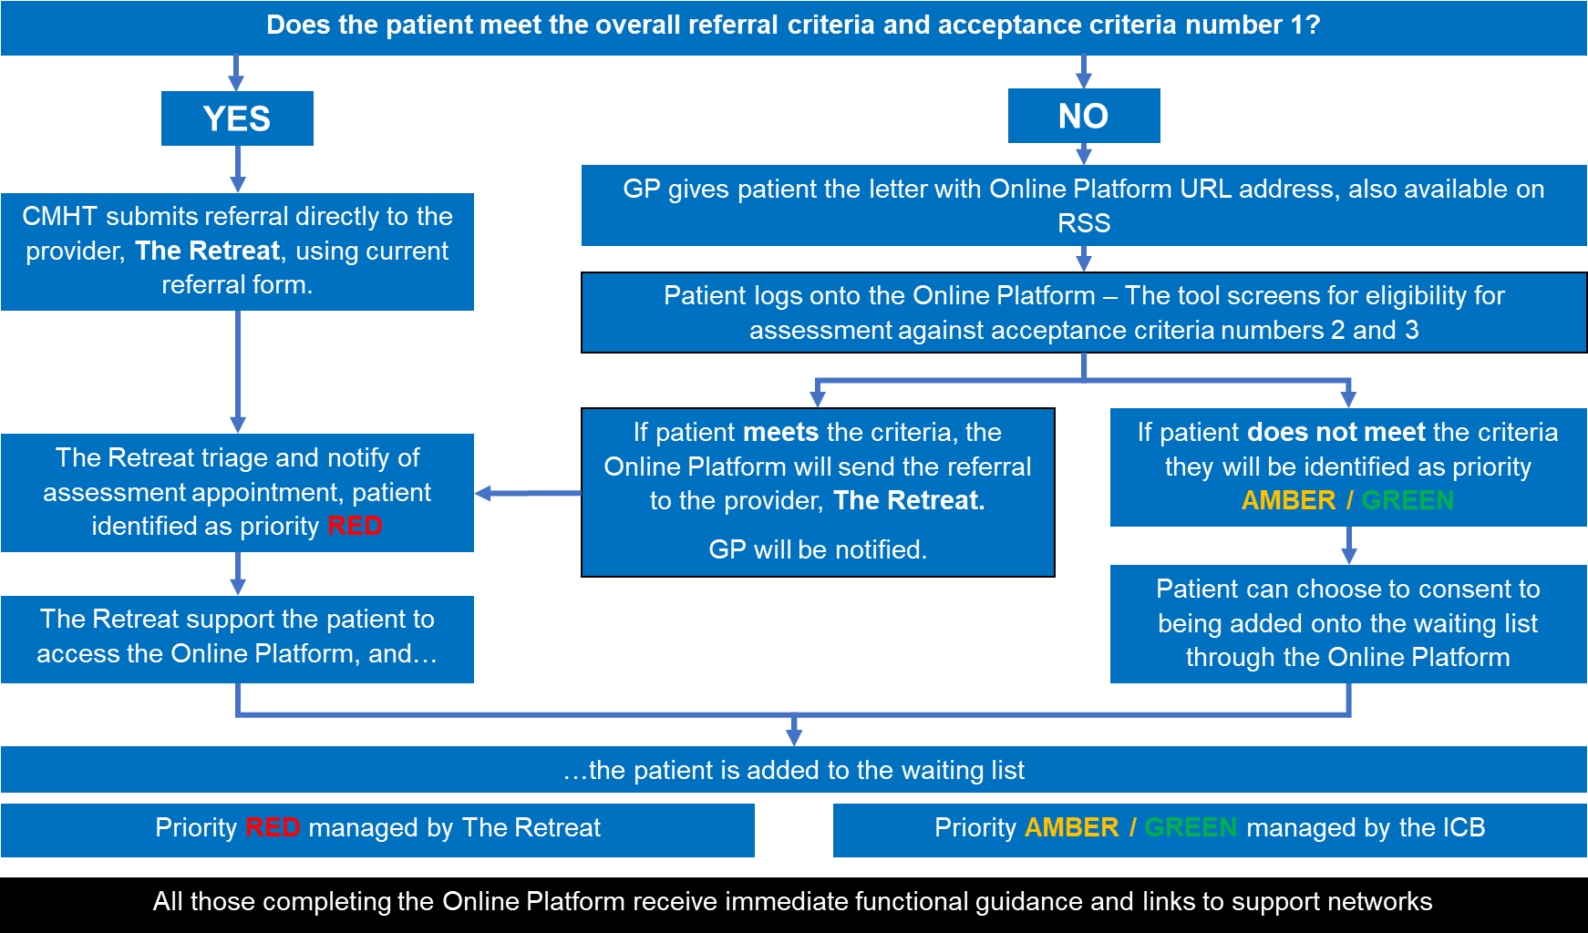

Priority Amber/Green patients: If a person's circumstances change which results in their meeting the acceptance criteria at any point, they can be re-referred for triage as Priority Red via their GP or Community Mental Health Team.

