Transdermal Patch Application Record
Name | Name and strength of patch and directions for administration (as written on label)
DOB
Prepared by: | Checked by: | Date:
Mark “x” to show where patch is applied – see patient information leaflet for recommended sites.
Ensure site of application is rotated as given in the patient information leaflet.
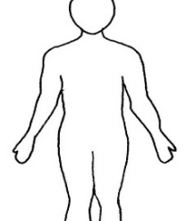  Front | 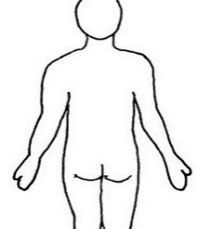  Back | Date patch applied:  Time:  Signature:  Date next patch due: | Date patch removed:  Time:  Signature:
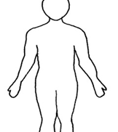  Front | 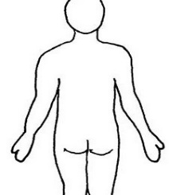  Back | Date patch applied:  Time:  Signature:  Date next patch due: | Date patch removed:  Time:  Signature:
Front | 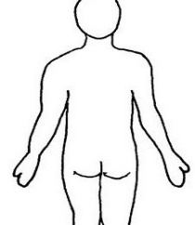  Back | Date patch applied:  Time:  Signature:  Date next patch due: | Date patch removed:  Time:  Signature:
Front | Back | Date patch applied:  Time:  Signature:  Date next patch due: | Date patch removed:  Time:  Signature:
Front | 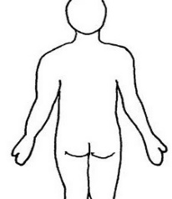  Back | Date patch applied:  Time:  Signature:  Date next patch due: | Date patch removed:  Time:  Signature:
Front | Back | Date patch applied:  Time:  Signature:  Date next patch due: | Date patch removed:  Time:  Signature:
Front | 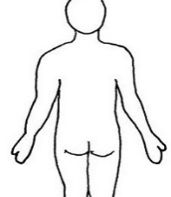  Back | Date patch applied:  Time:  Signature:  Date next patch due: | Date patch removed:  Time:  Signature:

